Foundation Package Deployment Guides
Version 1.3.3

Last Updated Date: October 31, 2025
Last Updated By: Marco Bertucci
Table of Contents
Solution Overview 6
Finance Data Model (Dimensions & Descriptions) 6
Solution Components 7
Step 1 – Configure the Hierarchies 9
Account Dimension 9
Entity Dimension 10
Department Dimension 10
Placeholder 1, 2, 3 & 4 Dimensions 11
Year Dimension 11
Period Dimension 11
Scenario Dimension 11
Currency Dimension 11
Measure Dimension 12
Data Model Tagging 12
Step 2 – Upload the Client GL Data Manually 13
GL Data Load Overview 13
Transform the Raw GL Extract into an Intersection File 13
Validate the Data Model Structure – Unmapped Members 14
Validate the Data Aggregation 15
Balancing your Balance Sheet 15
Checking Retained Earnings 15
Configuring Retained Earnings within the Account Dimension 16
Retained Earnings Diagnostic File 17
Setting up the Retained Earnings Diagnostic Template 17
Step 3 – Setting up the Foundation Reports 18
Corporate Financial Statements.xlsx 19
Functional Overview 19
Template Structure 19
Mapping 19
Report Configuration 23
Frequently Asked Questions 25
Income Statement by Department 26
Functional Overview 26
Template Structure 26
Mapping 26
Income Statement Variance 27
Functional Overview 27
Template Structure 27
Mapping 27
Conditional Formatting 28
Cash Flow Report 29
Important Note 29
Functional Overview 29
Template Structure 29
Report Configuration 30
Step 4 – Setting up the Foundation Templates 33
OPEX Planning Input Template 34
Functional overview 34
Template Structure 34
Mapping 35
MDR Expressions 37
Template Configuration 37
Drivers Set up 39
Frequently Asked Questions 40
Revenue and Cost of Revenue Planning Input Template 42
Functional overview 42
Template Structure 42
Drivers Set up 42
Planning Method Input Template 44
Functional and Technical overview 44
The ETL Template 45
Input Tab Configuration 45
Template Configuration 46
Frequently asked questions on the Driver-based logic 47
Balance Sheet & Cash Flow Planning Input Template 49
Functional overview 49
Technical Overview 49
Template Structure 50
Mapping 51
Template Configuration 51
Balance Sheet & Schedules Tab 53
Cash Flow Statement Tab 61
Frequently Asked Questions 70
Step 5 (Foundation) - ETL Packages 72
Covered Requirements 72
Data Extraction 74
Foundation Data Load - Direct Method 75
Solution Highlights 75
Integration Structure 75
Testing the Direct Method ETL Template 76
Foundation Data Load - Simple Method 77
Solution Highlights 77
Foundation Data Load - Advanced Method 78
Solution Highlights 78
Integration Structure 79
Setting the Advanced Method Channels 81
Setting the Advanced Method ETL Template 82
Testing the Advanced Method ETL Template 83
How to get the Opening Balance? 84
What is an Opening Balance? 84
How to get the Opening Balance in the cube? 84
What to do next? 84
Foundation Data Load - General FAQ 86
Data Load Automation 90
Enablement Sessions (Foundation) 91

Solution Overview

Finance Data Model (Dimensions & Descriptions)
Below is an overview of the Standard Finance Data Model (1.1 – Finance) that comes with the Foundation and Foundation Fundamentals Package.

Dimension | Description
Account | This dimension carries the Chart of Accounts (CoA), which includes the P&L ("Net Income" parent), Balance Sheet and Other Account roll-ups used in the templates and reports from the Foundation library.
Entity  (Shared Dimension) | This dimension carries the Entity roll up, used to differentiate the client legal entities ("ABC corp Canada", "ABC corp US", "ABC corp consolidated", etc.).
Department  (Shared Dimension) | This dimension carries the Department roll up, used to differentiate the different departments / operating units.
Placeholder 1 | Placeholder dimensions are provided and can be re-used to carry other client dimensions required to support the implementation ("customer", "product", "project", etc.)
Placeholder 2 | Placeholder dimensions are provided and can be re-used to carry other client dimensions required to support the implementation ("customer", "product", "project", etc.)
Placeholder 3 | Placeholder dimensions are provided and can be re-used to carry other client dimensions required to support the implementation ("customer", "product", "project", etc.)
Placeholder 4 | Placeholder dimensions are provided and can be re-used to carry other client dimensions required to support the implementation ("customer", "product", "project", etc.)
Year  (Shared Dimension) | This dimension carries the calendar year roll up (flat list of years).
Period  (Shared Dimension) | This dimension carries the Full Year and Year-to-Date monthly roll ups.
Scenario  (Shared Dimension) | This dimension carries the different scenarios used to differentiate Actuals versus Plan versus Archived Scenarios (i.e. versioning of the Plan scenario for closed periods).
Currency | This dimension supports the currency conversion module (Currency). It will carry by default a "Local" member.
Measure | This dimension carries all the measures used across the templates and reports of the Foundation library.

Solution Components
Below is an overview of the various Vena components that come with the Foundation and Foundation Fundamentals packages.

Process | 1.1 – Foundation: Financial Reporting & Planning Process  OR  1.1 – Foundation: Fundamentals
Data Cube | 1.1 – Finance
Files Library (Templates) | Template Studio Templates (these Templates are in scope for foundation implementations, but are generated using template studio – please see How-To: Mapping Standard Vena Templates with Template Studio):  - OPEX Planning Input Template  - Revenue and Cost of Revenue Planning Input Template  - Balance Sheet Report (formerly Corporate Financial Statements)  - Income Statement Report (formerly Corporate Financial Statements)  - Income Statement Variance  1.1 – Foundation Templates:  - Balance Sheet and Cash Flow Planning Input Template*  (this template is not included with Fundamentals)  1.2 – Foundation Reports:  - Income Statement by Department*  (this template is not included with fundamentals)  - Cash Flow Report  1.3 – Foundation Controls:  - Beginning Balance Input Template  - Planning Method Input Template  “0 - Vena Tools” (Folder + Files)
Calc Scripts | RE Month-over-Month Roll Calc  RE Year-over-Year Roll Calc
Data Transformation (Folders) | 1.1.0 – FIN_Utility  1.1.1 – FIN_Planning Method Maintenance  1.2.2 – FIN_Data Load  1.1.3 – FIN_Historical FX Maintenance
ETL Templates | 1 – Planning Method Maintenance  2.1 – GL Data Load – Direct Method  2.2 – GL Data Load – Advanced Method  3 – Historical FX Maintenance  File to Cube (Hierarchy)  File to Cube (Values)
You can view all Foundation and Foundation Fundamental components on the demo tenant: solutionpackagedemo.com. For access, please reach out to solutionpackageteam@venacorp.com.

Step 1 – Configure the Hierarchies
Before You Begin…

Before starting this step, you need to have:

- Received client’s hierarchies (recommend leveraging Quick Start)
- Pre-configured the Finance Data Model and deleted unnecessary members. You may choose to utilize the integration channels within “1.1.0 - FIN_Utility” to remove any demo and/or currency members (which are tagged with “Demo” and “Currency” attributes).

In addition, it is important to know that the templates and reports within the Foundation Package are dynamically mapped to specific standard parent members. Deletion of these standard parent members could result in broken mappings within the provided templates. Standard members within each dimension are discussed below.

Account Dimension
The Net Income parent member contains a default P&L roll up structure that is configurable. You can upload any type of roll up structure and GL account underneath the different levels of this tree and the templates will automatically populate with these members.
You will need to upload the client hierarchies as children underneath the pre-existing standard parents to retain the mapping integrity on the template side.
Standard members (for Net Income):
- Net Income
  - EBIT
    - Gross Margin
      - Revenue
      - Cost of Revenue
    - Operating Expenses
  - Other Income/Expenses
  - Income Tax Expenses/Benefit
Same logic for the Balance Sheet parent member. You can delete this roll up if your client doesn't require a Balance Sheet.
Standard members (for Balance Sheet, if leveraged):
- Balance Sheet
  - Assets
    - Current Assets
    - Non Current Assets
  - Liabilities
    - Current Liabilities
    - Long Term Liabilities
  - Stockholders Equity
    - Retained Earnings
The Other Accounts parent member contains members that can be used to store any type of stat accounts the client wants to use:
- The KPI and Ratios member itself is not used/mapped anywhere and can be deleted if needed.
- Currency members can be deleted by executing the FIN_Utility_STEP 1_Delete Currency Members channel within the utility integration folder
- Cube to Cube (C2C) members
- Balance Sheet Planning and Cash Flow Statement members

Entity Dimension
The All Entities parent member needs to remain untouched, since it's mapped as a page mapping on most templates and reports. Outside of that, you can upload your entity tree underneath.
The All Entities by Source Currency parent member is only driving some mappings in the Currency Conversion Check Report. You can delete this member by executing the FIN_Utility_STEP 1_Delete Currency Members channel within the utility integration folder.

Department Dimension
The All Departments parent member needs to remain untouched, since it's mapped as a page mapping on most templates and reports. Outside of that, you can upload your department tree underneath.
If you need a parallel hierarchy to support a different type of organizational view in your reports, feel free to create it as sibling to All Departments.
Be careful with templates/reports using multi-dynamic rows (MDRs). Shared members will appear twice if you map such members in your expression (e.g. Detailed Income Statement).

Placeholder 1, 2, 3 & 4 Dimensions
They are statically mapped on the templates/reports and channels using the Undefined member.
In case you need to use these dimensions, just upload your hierarchy tree wherever you need it and make sure you remap this dimension manually on your reports, templates and integration channels (channel mappings, sources & destinations).

Year Dimension
You shouldn't have to change anything, outside of adding new year members if needed within the All Years parent member.

Period Dimension
The P0 member name should remain untouched (as it is used in Channels and calcs to capture beginning balances as required).
Under Full Year and YTDs parent members, you can only change the alias of the bottom level period members in case you are working with Fiscal periods and that the first month of the year is not January.
Feel free to create an alternate hierarchy or additional dummy members if needed as siblings of those 2 hierarchies.

Scenario Dimension
The member Actual should remain untouched (it's used on all templates and reports using form variables (FVs), and "Actual" is hard coded in the formulas)
Plan is not statically mapped but referenced as a Process Variable or Form Variable in the Templates and Reports in the Foundation library. It can be renamed as required.

Currency Dimension
The Local member should remain untouched, since it's mapped as page on most templates and reports.
The All Entities by Source Currency parent member is only driving some mappings in the Currency Conversion Check Report. You can delete this member by executing the FIN_Utility_STEP 1_Delete Currency Members channel within the utility integration folder.

Measure Dimension
Value is the default member used to store all the financial data (actuals and plan). The parent Total Value is typically used for mapping of Actuals, whereas Value is used for mapping of plan values (bottom-level member). These members should remain untouched, since it is column mapped on most templates and reports.
The Other measures parent includes additional measures:
- Planning Method Drivers contains a set of measures to support the Driver-based OPEX template from the Foundation module. These members need to remain untouched.

- FX Currency Measures is used to apply the Currency Conversion Module. You can delete this member by executing the FIN_Utility_STEP 1_Delete Currency Members channel within the utility integration folder.
The Override measures parent is a parallel hierarchy, simply here to help define the exception for the "zero deletion" feature (see Settings tab under Modeler). The idea is to leverage this product feature to automatically delete all the zeroes from the cube except for the ones sitting on this "override" slice. The purpose is to save space in the cube (otherwise most templates with formulas in locked cells would be saving back zeroes to the cube). More details on this set up are available here.

Data Model Tagging
Data Model Standardization (DMS) is comprised of a set of Dimension Types and Standard Members that serve to convey a Vena Standard definition of common dimensions and members. They are used as references in various product components including Vena Insights, Vena Copilot, Vena Functions, QuickStart and Template Studio.

Ensure your data model is tagged. The Finance Data Model comes pre-tagged, but you should check the tags are still applied after the hierarchy is built. For custom data models, the consultant will need to tag the data model.

Learn more about data model tagging here: Data Model Standardization.

Step 2 – Upload the Client GL Data Manually
Before You Begin…

Before starting this step, you need to have:

- The client raw GL data extract for the current year to date (.csv or Excel format).
- The offline version of the client Income Statement and Balance Sheet report

The objective of this step is not to build a Data Load ETL Template yet, but just a matter to review your hierarchy’s completeness and facilitate the Workshop Discussion.

Please be aware of latest Quick Start updates. Quick Start is used to facilitate and enable a new customer setup faster. The goal is to reduce complexity and create experience for new customers to collaborate with consultants and eventually take on some set-up work (i.e. replace some of the steps taken here).

GL Data Load Overview
Now that the Finance Data Model is fully configured, the next step of deployment is to transform and load manually the client raw GL data file provided by the client.
The goal of this step is to:
- Make sure that the data provided is aligned with the data model structure created (i.e. make sure there are no Unmapped members in the data model), which will help validate that the structure of main hierarchies supporting the solution (Account, Entity, Department) built are correct and exhaustive.
- Identify what type of data scrubbing or mapping are required to transform the client data into an intersection file format.
- Make sure the data flows properly into the Foundation Reports.
- Make sure the numbers in the Income Statement and Balance Sheet tie out with the client offline reports (general financial data consistency).

Transform the Raw GL Extract into an Intersection File
Take the GL actuals data file provided by the client and manually transform it into an Intersection upload file that matches the Data Model structure.
Before loading the file make sure:
- Each header has an underscore "_" as the leading character
- It's best practice to run a hierarchy extract from the cube and run lookups on every member in the intersection file you are about to upload for each dimension, to make sure the leaf levels exist in the data model prior to the load (objective: anticipate unmapped members before they are even created).
Upload the file and check that the load status is complete. If not, review and repeat the above until it completes
Tip: To easily remove data afterwards, you can load the data on a “test” measure or scenario and change the mappings in your reports. This way, you can easily delete the “test” data by deleting the member afterwards.

Validate the Data Model Structure – Unmapped Members
After the load is complete, go back to the Modeler > Data Model tab.
Go dimension by dimension and check if you see an Unmapped parent at the bottom of each hierarchy.
For the dimensions that have an Unmapped parent folder, expand the folder and check what members you see in there:
Situation 1: The member is invalid and results from a data manipulation error in the .csv upload file.
The order of dimensions in the upload file was inconsistent with the data model structure (the orders of the columns were flipped in the upload file) and resulted in members from one dimension being loaded accidentally in the wrong dimension.
- Resolution: Delete the unmapped parent altogether, modify your upload file and reload it.
The headers of the upload file missed an "_" and ended up being loaded as members.
- Resolution: just delete those members one by one under the unmapped folder of each dimension.
Some members on your data model have leading zeroes, and you lost the zeroes as you were working in the upload file in Excel.
- Resolution: delete the unmapped folder altogether, go back in your upload file and modify the members to include a leading zero (either by changing the format of the column to text, or using Excel formula logic like left, mid, etc.).
Situation 2: the member is valid but was simply not included in the data model
This is especially likely on the Account dimension (missing GL accounts).
- Resolution: List out those accounts in an email and send them over to the client. They will need to provide the alias for those accounts and their position in the main roll up.

Validate the Data Aggregation
See files library > 0 – VenaTools > Data Check Report.xlsx

- Entity, Department, Currency & Account are driven by the selection from the choose box (MEMBER_CELL), so you can easily filter between all or a specific entity/department/currency/account and subgroups. Please note that the currency selection is preset to always be bottomlevel('All Currencies') since it doesn’t make sense to aggregate different currencies.
- The PV Overrides are also set up, so you check for any Year/Period/Scenario, different than the ones driven by the Process Variables.
- MDRs have zoom in enabled, so you can easily zoom in/out on children/bottomlevel/descendants to review the operator signs & roll-ups.

Assumptions: Ending balances for B/S accounts are stored at the period level. If not, map the Balance Sheet to a different block using YTD roll-up for the periods.
Instead of using this report, you could create an Ad-hoc Report.

Balancing your Balance Sheet
Your top priority before continuing with building more reports would be to tie out your Balance Sheet Statement. If your Actuals do not balance, you should review the following:
- Your customer data didn’t balance in the first place.
- You have unmapped members or wrong operator sign in your hierarchy.
- Your retained earnings does not roll-forward as expected. Please review the following article to help you diagnose your Retained Earnings calculation. Please see Checking Retained Earnings below.

Checking Retained Earnings
See files library > 0 – VenaTools > Retained Earnings Diagnostic.xlsx

This template is meant to enable consultants to balancing Retained Earnings as opposed to being customer-facing.
When working with Retained Earnings, the main question is how often Net Income is cleared to this account. There are three possible scenarios:
- Net Income is cleared monthly.
- Net Income is cleared annually.
- Net Income is never cleared.
The answer to the above will determine which calcs you need to implement for your client. The “Retained Earnings Diagnostic” template (for which documentation is below) is meant to help you answer this question.
Scenario | Required Calc(s)
Net Income is cleared monthly | No calcs required
Net Income is cleared annually | “RE Month-over-Month Roll Calc”
Net Income is never cleared | “RE Month-over-Month Roll Calc”  “RE Year-over-Year Roll Calc”
NOTE: When implementing either of these calcs, you must update the scope of the calc script(s) to match any updated placeholder dimensions (if you are leveraging the placeholder dimensions). The scripts must be updated to include .Leaves() for these updated dimensions to write to bottom level intersections.
For example, if you updated the dimension ‘Placeholder 1’ to ‘Product’, then the calc script will need to be updated from [Placeholder 1.Undefined] to [Product.All Products].Leaves()
This is to ensure the calc script(s) writes to bottom level intersections.
It is highly recommended you balance Retained Earnings in local currency first before applying FX logic.

Configuring Retained Earnings within the Account Dimension
Two calcs are potentially needed to facilitate rolling Retained Earnings forward. As such there are two target accounts (one for each calc):​​​​​​​
- Retained Earnings - Previous Year Carryforward is the target for the “RE Year-over-Year Roll Calc”
- Retained Earnings - Current Year Cumulative Income is the target for the “RE Month-over-Month Roll Calc”
Your client’s natural Retained Earnings and Dividends Paid GL accounts (e.g. 3500 and 3510) should roll up to the Retained Earnings parent that comes with migration. The two accounts that act as calc targets should be viewed as being complimentary to the natural GLs that are in your client’s ERP. Note the Retained Earnings parent is mapped on the Balance Sheet.

Retained Earnings Diagnostic File
See files library > 0 - Vena Tools > Retained Earnings Diagnostic.xlsx

The purpose of this file is to help you determine which calcs you need to deploy in order to balance your client’s Balance Sheet. When both the check marks are green, Retained Earnings are balanced.

It is recommended you re-check the Balance Sheet after the above is complete.

The green check marks beside the calculator names indicate that both calcs have run properly or are not required, if a calc needs to be run, you will see a red “x”.

In this case you will need to trigger the “RE Month-over-Month Roll Calc” before triggering the “RE Year-over-Year Roll Calc”.

Setting up the Retained Earnings Diagnostic Template
Under the Mappings Control section, there is a cell that hosts the account dedicated to dividend payments.

It is common for companies to not have an account dedicated for this; in this case you can leave this blank. The appearance of the “Input” tab will change to allow for inputting dividends manually.

You only need to input values into these cells in case dividends have not already been cleared to retained earnings, note you will need to input cumulative YTD dividends.

Step 3 – Setting up the Foundation Reports
Before you begin…
You need to have:
- Completed all the previous steps (migration, data model setup, manual GL data load).
- Collected offline versions of the client Income Statement and Balance Sheet report to tie out the numbers with your Vena report.
Now that the client GL data has been loaded, the next step of deployment is to set up the Reports.
The Foundation Package contains the following reports:
- Corporate Financial Statements
- Income Statement by Department (not included with Fundamentals)
- Income Statement Variance
- Cash Flow Report
Note the general template structure, mapping and report configuration across all these reports are generally similar (apart from the Cash Flow Report), with some minor noted differences.

Corporate Financial Statements.xlsx
Important Note: The Balance Sheet Report and Income Statement Report are both available via Template Studio. Template Studio provides a wizard experience that allows Vena users to easily map templates and reports. Template Studio gives you a starting point for mapping your templates that you can customize later, saving you time and helping you implement Vena faster. Please see How-To: Mapping Standard Vena Templates with Template Studio.

Functional Overview
The Corporate Financial Statements Report is meant to be used by corporate, region or department managers to report on monthly Actuals to date and plan to year-end, for one or multiple entities and department(s) at a time. It provides them with a high-level view of their Income Statement, a detailed Balance Sheet, and respective KPIs by Entity or Department and a defined currency.

Template Structure
The template contains 2 tabs (excel sheets):
IS tab (Income Statement):
- Shows Prior Year, Current Year, and Plan Year (CY+1)
  - A Plan Year +1 is also included (CY+2) within hidden columns, that can be leveraged as needed.
- You have up to 10 account groupings (categories) to populate your final Net Income.
  - Children of these account groupings are displayed in rows.

BS tab (Balance Sheet):
- Shows Prior Year, Current Year, and next Year (CY+1)
  - A Plan Year +1 is also included (CY+2) within hidden columns, that can be leveraged as needed.
- You have up to 10 account groupings (categories) to populate your final Balance Sheet (Ending Balance).
  - Bottomlevel of these account categories will be displayed in rows.

Mapping
Mapping is summarized in the Rough Work Area (RWA) on the top-left portion of each associated tab.

The RWA contains three (3) areas:

- The “Summary” Section (“SummaryBS” for BS tab)
- The “Selection” Section (Only on the IS tab)
- The “Variables”

“Summary” Section:

Provides an overview of the different dimension mapping that is used on the sheet you are working on and mapped to Section: Summary (on the IS tab) and Section: SummaryBS (on the BS tab). Looking at the screenshot below, we can see that Account, Entity and Department mapping on the IS Tab (Section: Summary) is mapped in Rows via multi-dynamic row mapping (MDRs). The Placeholder (1-4) and Currency dimensions are page mapped. Year, Period, Scenario and Measure are all column mapped. You may notice that Year, Period and Scenario are referencing process variables. The cells are not actually mapped (within D11, D12 and D13); rather, they are using excel formulas to bring in process variables. These cells are then referenced further below in the “Variables” area, and are column mapped using form variables. See the “Variables” section and subsequent Important Note further below.

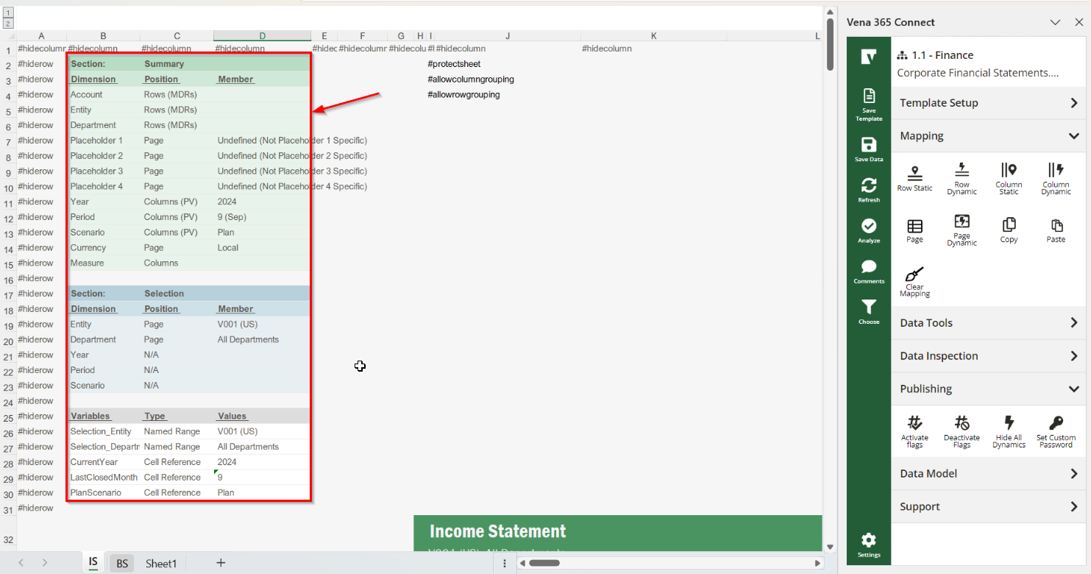

“Selection” Section:

This section is mapped to Section: Selection and contains dynamic page mappings that are to be used as choose (filter) options within your template. The defaulted choose options are for Entity and Department selections.

You can add other dynamic page mappings as required (previously noted as overrides). In some instances, you may want to use an override to dynamically select what choose (filter) option is being applied to the template, rather than referencing a process variable. For example, the Year dimension is column mapped within the template as noted in the Summary RWA. The CurrentYear cell (cell D28) is refencing the process variable being brought in (using the screenshot above, it is 2024). If you were to dynamically page map bottomlevel(“All Years”) to Section: Selection (in cell D21), the CurrentYear Cell (cell D28) would reference the selected Year (in cell D21), as opposed to the process variable (in cell D11), which is being used as column mapping within the template.

“Variables”:

Variables are specific cells that are to be used as named range references and/or cell references within your template. These are not mapped cells.

For example, the Selection_Entity and Selection_Department named ranges (which would be cells D26 & D27 in the screenshot above) simply reference the page mappings within the “Selection” Section (cells D19 & D20). These named ranges are referenced in the MDR mapping queries for the entity & department dimensions. For example, the department dimension is mapped within the MDRs as bottomlevel(selection_department), so that if “All Departments” is selected, you see a breakdown of each individual department.

As another example (using the screenshot above), the CurrentYear process variable is being brought into the template via excel formula =PVCurrentYear (in cell D11). This is being referenced within the Variables section (cell D28), with some excel logic to remove any associated alias name and use an override if one is present. This cell within the variables section (cell D28) is being referenced within form variables (mapped to Section: Selection) further right in the template as column mapping. A screenshot of this is provided below.

In short, the Variables section is meant to provide a central location for cell references being used within the sheet you are working on.

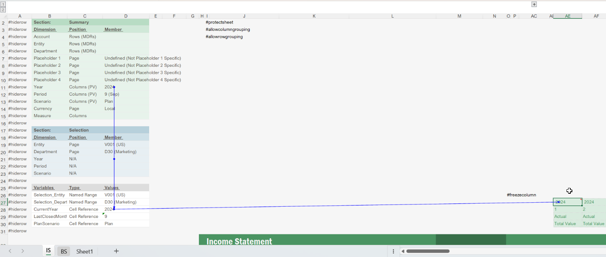

Important Note:

Important Note:

Within V365, process variables can simply be refenced via excel formulas. Example: A process variable with the name “CurrentYear” can be referenced within a template by inputting =PVCurrentYear within an excel cell (i.e. prefix “PV” with the name of the process variable).

However, within the desktop add-in, newly added process variables will not update using this logic.
Adding process variables with the desktop are required to be mapped. You cannot map them to the summary section, because these dimensions are already column mapped (via form variables), and a dimension cannot be mapped to two different locations (i.e. cannot have dimension mapped to both “page” and “column” in the same section).

So what?

There are two ways around this:

- If possible, add in process variables to your template using V365 (i.e. a formula with the prefix “PV” and the name of the process variable), refresh and save your template in V365. When you reference a process variable in V365 and refresh, the process variable is updated with backend logic to sync with the desktop add-in so that it will update accordingly when the template is opened via the desktop add-in.
- If only the desktop add-in is available for managing your templates, then map your process variables to a new section (so it does not overlap with dimension mapping in other sections) and reference it.

Note that the latest Foundation Templates are saved in V365, so the process variables that come with the Foundation Package are already synced (and will update accordingly) in both V365 and the Desktop add-in. This important note is really only applicable for when new process variables need to be added.

Report Configuration
Groupings

Easily navigate and configure groupings on the fly via input cells. You have up to 10 account groupings (categories) to map to populate your Net Income, and the same for the Balance Sheet. Simply input the member name within the yellow input cell, which are each pre-assigned with named ranges, that are referenced in adjacent MDRs and Subtotal amounts (Block B1). Using the screenshot example below, the member name “Revenue” is inputted for Group1 on the Income Statement Tab, so that the adjacent Account MDR Mapping (cell L40) and the Account Row Mapping Total (cell D49) reference this value. As previously noted, Children of these account groupings are displayed in MDRs for the IS tab, and Bottomlevel for the account groupings on the BS tab.

Operators are included (where applicable) to determine whether the group should be added or subtracted from the subtotal being displayed (eg. Cost of Revenue as negative/positive value respectively will give you Gross Margin = Revenue +/- Cost of Revenue).

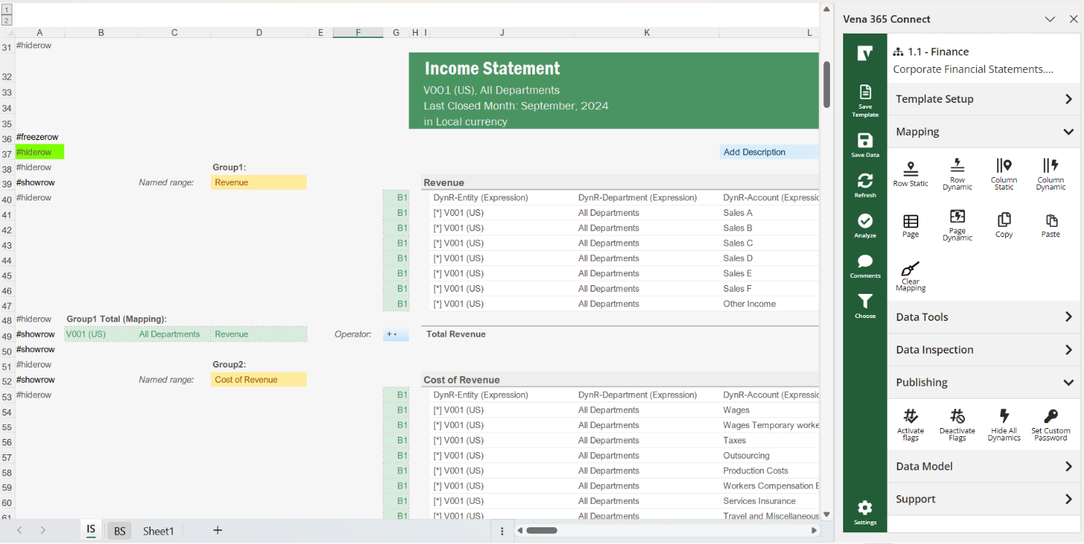

Set Your Fiscal Start Month

The fiscal start months displayed in all Foundation templates and reports are controlled by the date displayed in the first Current Year Actual header.
For example, if you have a fiscal start year beginning in February, your data model would be 1 (Feb), 2 (Mar), 3 (Apr)… and so on. To update your template accordingly to match this fiscal start year, you would update the formula in the first Current Year Actual header from =DATE($D$28,1,1) to =DATE($D$28,2,1) so that the first month displayed in the header would be February. Once updated, all the other monthly headings within the template / report will update accordingly.
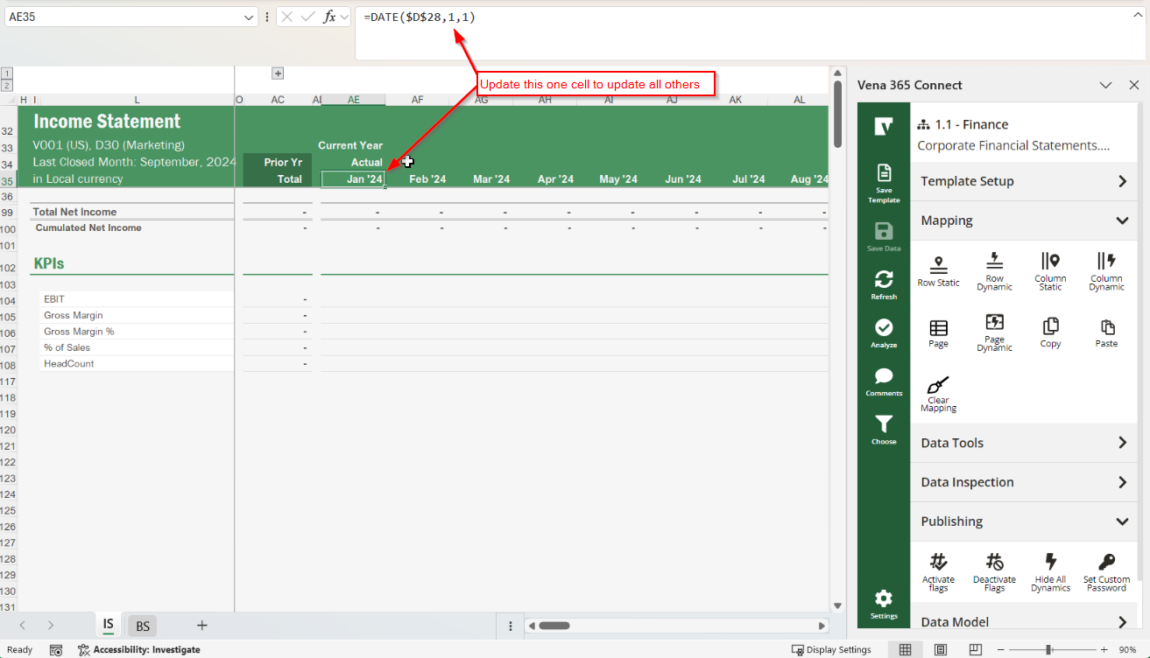
Other Template Configurations to Consider
- Enable LIDs (if required)
- Enable Zoom-in/out (if required)
- Enable Cascade (if required)
KPIs

Same as the mapping controls, you have up to 10 placeholders to map to retrieve KPIs data you may have saved in the cube to display in the BS tab.

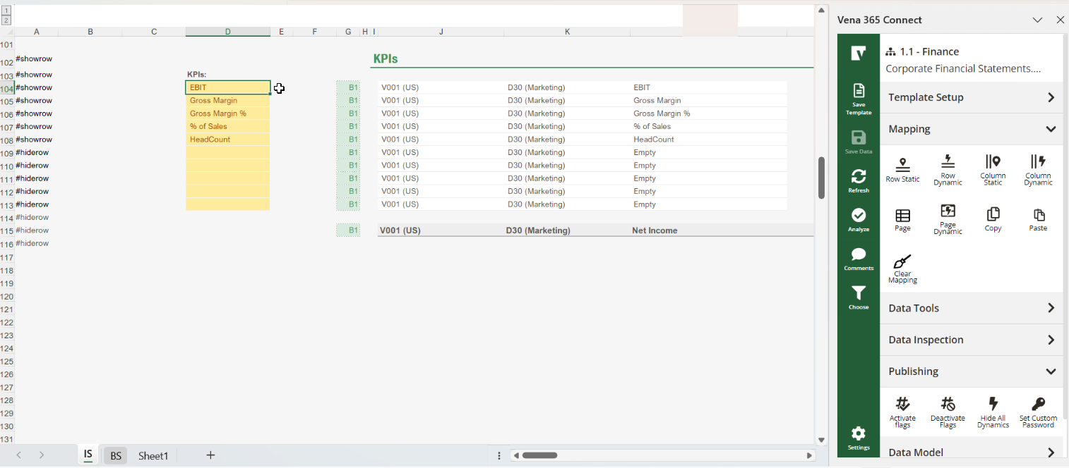

Frequently Asked Questions

What if I want to show rows with no data?

The template is using MDR expressions to leverage further functionalities (eg. Zoom-in/out, show rows with no data). In the case you would like to show all the accounts (even the ones with no data), simply go to the MDR expression settings and uncheck “Treat Zeros as Blanks” and “Hide Blank Rows”.

Be careful, as this may drastically impact on the performance of your template (in cases where you have a lot of accounts).
What if I need to add an extra account grouping / category?

Simply insert rows for new grouping and utilize the same logic as previous groupings as required. You can typically do this by copying an existing group and pasting/inserting it underneath. A few things to keep in mind:

- Ensure your newly added grouping is captured within the Subtotal
- Create a new named range for your additional grouping, for the yellow input cell (e.g. Group11).
- Ensure that your account dimension for the MDR and the group total amount reference this new input cell/grouping.

Income Statement by Department
Note: This template is not included with Foundation Fundamentals.
Please review the Corporate Financial Statement, as The Income Statement by Department Report structure is very similar to the Corporate Financial Statements. This article mainly highlights the main differences.

Functional Overview
The Income Statement by Department Report is meant to be used by corporate, region or department managers to report on Actuals to date, QTD and YTD, for one or multiple entities at a time. It provides them with a detailed view of their Income Statement and main KPIs by Department and a defined currency.

Template Structure
It follows the same architecture as the Corporate Financial Statements. The main differences are:
- Department is displayed in columns, and not in rows.
- Actuals are displayed as PY, MTD, QTD, YTD.

Mapping
It follows the same architecture as the Corporate Financial Statements. The main differences are:
- In the “Summary” Section, the scenario dimension is page mapped to “Actual”.
- The MDRs within the sheet only include Entity and Account dimensions. Department dimension mapping is dynamically mapped to the columns. The dynamic expression within the columns for the Department dimension is set as: CHILDREN(MEMBER_CELL(Selection_Department))

Income Statement Variance
Important Note: This report is available via Template Studio. Template Studio provides a wizard experience that allows Vena users to easily map templates and reports. Template Studio gives you a starting point for mapping your templates that you can customize later, saving you time and helping you implement Vena faster. Please see How-To: Mapping Standard Vena Templates with Template Studio.
Please review the Corporate Financial Statement, as The Income Statement by Department Report structure is very similar to the Corporate Financial Statements. This article mainly highlights the main differences.

Functional Overview
The Income Statement Variance Report is meant to be used by corporate, regional or department managers to do ad-hoc Variance analysis on Actuals and Plan to date, QTD and YTD, for one or multiple entities and department(s) at a time. It provides them with a detailed view of their Income Statement and main KPIs by Entity or Department.

Template Structure
It follows the same architecture as the Corporate Financial Statements. The main differences are:
- Variance columns are included to compare Actuals vs Prior Year and Actual vs Plan as MTD, QTD and YTD.

Mapping
It follows the same architecture as the Corporate Financial Statements. The main differences are:
- The column layout has changed to be mapped to three (3) areas that include:
  - Variance analysis for Month-to-date
  - Variance analysis for Quarter-to-date
  - Variance analysis for Year-to-date
- Each of these three (3) areas has six (6) columns for:
  - Current year actuals
  - Prior year actuals
  - Variance between current year actuals / prior year actuals (% amount)
  - Variance between current year actuals / prior year actuals ($ amount)
  - Current year plan
  - Variance between current year actuals / current year plan (% amount)
  - Variance between current year actuals / current year plan ($ amount)

Conditional Formatting
The Data Bars in the Income Statement Variance Report are managed via conditional formatting.
Conditional Formatting has been edited to show red bars for negative impact (Cost Growth) and green bars for positive impact (Revenue growth) on the Net Income Total.
To manage the Conditional Formatting, go to Home > Conditional Formatting > Select “This Worksheet” > Select a specific rule, then click on “Edit Rule”.

Cash Flow Report

Important Note
The Cash Flow report is much different than most standard planning reports. Cash Flow accounts are not part of the standard Finance Cube chart of accounts, and therefore specific configuration is required to display the month-over-month changes (deltas) between two balance sheet accounts to determine the cash flow amounts. It is best practice to review the information contained here along with the information contained within the Balance Sheet & Cash Flow Planning Input Template overview, as many configuration options and data between these two reports/templates are similar.

Functional Overview
The Cash Flow Report is meant to be used by the corporate finance team to report on cash coming in and going out of the business on a monthly basis. Note that it is an indirect cash flow report, starting with the Opening Balance, showing Net Income, monthly cash flows from Operating activities, Investing activities and Financing activities. These activities determine the Net Change in Cash which is then used to determine the monthly Cash ending balance.

Template Structure
The template contains 2 tabs (excel sheets), one of which is hidden:
Cash Flow tab:
- Shows Prior Year, Current Year, and Plan Year (CY+1)
  - A Plan Year +1 is also included (CY+2) within hidden columns, that can be leveraged as needed.
- Includes various sections such as the Opening Cash Balance, Net Income, Cash Flows from Operating Activities, Cash Flows from Investing Activities, Cash Flows from Financing Activities and Cash Ending Balance.

Controls tab (hidden sheet):
- Configuration Options
- IS parameters (as related to the CF)
- CF parameters
- Workbook Variables & Settings
- Selection
- Sections
- Dates Management

Report Configuration
Much of the report is configured within the Controls tab. It is important to note that the Cash Flow activities are calculated by getting the month-over-month difference (delta) between the Actuals for the associated Balance Sheet (and in some cases, Income Statement) accounts.

Income Statement Parameters:

This section includes all the income statement parameters (Net Income and Depreciation Assets) indirectly involved in setting up the Cash Flow parameters (see below).

Cash Flow Parameters:

The Cash Flow parameters are broken into three sections:

- Operating Activities
- Investing Activities
- Financing Activities

Column B on the Controls Tab will display a number to relate to where it is populated within the Cash Flow Tab, which can also be seen within column B.

Operating Activities Configuration:

The configuration for Operating Activities contains the configuration for Cash, Net Income, Operating Non-Cash Activities (5 placeholders from actual accounts and 5 placeholders from input accounts), Depreciation assets (5 placeholders), Operating Assets (20 placeholders) and Operating Liabilities (15 placeholders).

There are 5 columns to configure columns for Operating Activities.

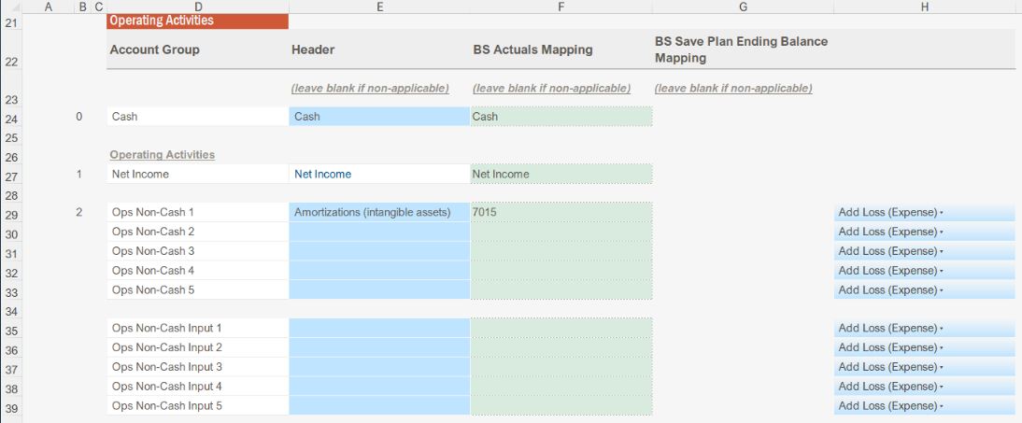

The first column (Account Group) should remain untouched, as these are the account groupings used on the Cash Flow Tab. The second column (Header) will determine how these groupings will display on the “Cash Flow” tab. Note that the Net Income and Depreciation headers will directly relate to what was inputted into the configured in the Income Statement parameters. The third column (HBS Actuals Mapping) is the associated Balance Sheet account associated with the Cash Flow Operating Activity. The fourth column (BS Save Plan Ending Balance Mapping) is only applicable where Balance Sheet Plan Ending Balances were saved back to input accounts (see Balance Sheet & Cash Flow Planning Input Template). The fifth and final column provides the option to determine whether activity should be an increase or decrease in the overall cash flow.

Investing Activities Configuration:

Investing Activities configuration is very similar to the configuration of Operating Activities; however, there are four (4) additional configuration columns for Accumulated Depreciation, Accumulated Depreciation (Planned), Header for Gain/Loss on Disposal Method and Gain/Loss on Disposal method mapping.

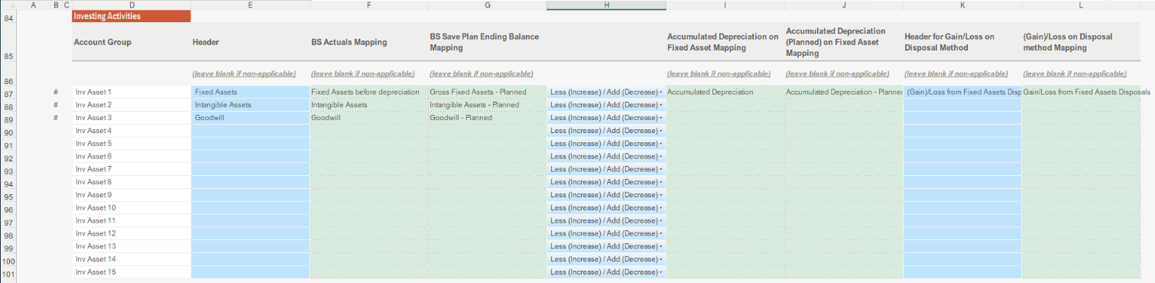

In the example above, you can see that these columns are typically used for Fixed Assets, where you would want to include any associated depreciation and/or disposal associated with fixed assets.

Financing Activities Configuration:

Financing Activities configuration is very similar to the configuration of Operating Activities.

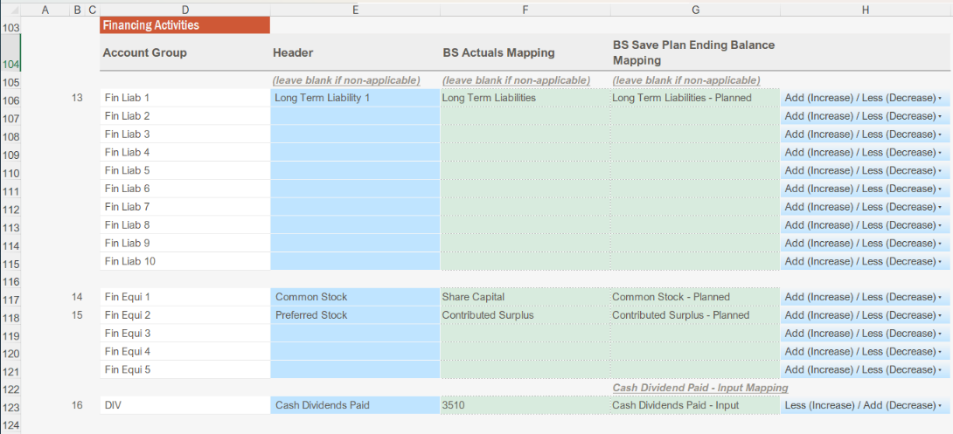

Cash Flow Tab

Once the above configuration options are set up the associated Balance Sheet (and in some cases, Income Statement) account Actuals will populate in hidden columns on the Cash Flow Tab. The month-over-month change (delta) between these accounts is what is used to calculate the Cash Flow amounts displayed on the report.

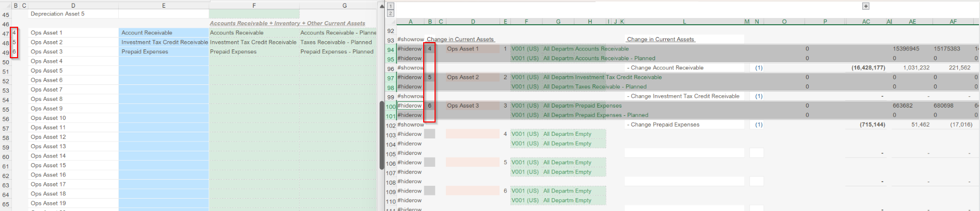

Step 4 – Setting up the Foundation Templates
Before you begin…

You need to have:

- Completed all the previous steps (migration, data model set up, manual GL data load, report set up and GL data validation)
- Overview of the Templates available in the Foundation Library

Now that your Vena reports are up and running, the next step of deployment is to set up the Templates.

The Foundation Package includes the following planning templates:

- OPEX Planning Input Template
- Revenue and Cost of Revenue Planning Input Template
- Planning Method Input Template (Foundation Controls)
- Balance Sheet Planning Input Template & Cash Flow Statement (not included with Fundamentals)
Note the general template structure, mapping and report configuration between the OPEX Planning Input Template and Revenue and Cost of Revenue Planning Input Template are generally similar, with some minor noted differences.

OPEX Planning Input Template
Important Note: This template is available via Template Studio. Template Studio provides a wizard experience that allows Vena users to easily map templates and reports. Template Studio gives you a starting point for mapping your templates that you can customize later, saving you time and helping you implement Vena faster. Please see How-To: Mapping Standard Vena Templates with Template Studio.

Functional overview
In the OPEX Planning Input Template, the planning of the Operating Expenses is performed either as direct input or through pre-set driver-based formulas or the planned amount is loaded in from another source. This reduces the number of manual inputs contributors typically need to do on a direct input template and expedites the forecasting process. The template is pre-configured for you to plan by a specific Entity/Department.

Template Structure
The template contains 2 tabs:
Input tab:
- It shows Prior Year, Current Year, and next Year (CY+1)
  - A Plan Year +1 is also included (CY+2) within hidden columns, that can be leveraged as needed.
- You have up to 10 account groupings to populate your final Operating Expenses.
  - Bottomlevel of these account groupings are displayed in the rows.
  - Group 1 defaulted to bottomlevel ‘Operating Expenses’. No modification is required to use the template; however, you can choose to separate the expense groups by using the additional groups and add more groups as needed.
- Within each account category, you have three (3) Planning Methods, each with an individual mapping block, pre-set with an MDR:
  - Direct Input (B1): This section is also LIDs enabled (with a pre-set LID Template row).
  - Driver-Based (B2): Ability to choose pre-set Driver Logic from a dropdown list
  - Other Source (B3): Values are locked, and you are not able to plan/edit the values on these accounts.

Controls tab:
- A Drivers table is included for configuration and allowing the different types of drivers to be leveraged on the input tab.

Mapping
Mapping is summarized in the Rough Work Area (RWA) on the top-left portion of the Input tab.

The RWA contains three (3) areas:

- The “Summary” Section
- The “Selection” Section
- The “Variables”

“Summary” Section:

Provides an overview of the different dimension mapping that is used on the sheet you are working on and mapped to Section: Summary. Using the screenshot example below, we can see that Account, Entity and Department mapping on the Input Tab (Section: Summary) is mapped in Rows via MDRs. Placeholders (1-4) and Currency dimensions are page mapped. Year, Period, Scenario and Measure are all column mapped. You may notice that Year, Period and Scenario are referencing process variables. The process variables are referenced via formulas within these cells and are not actually mapped within these cells (D11, D12 and D13).

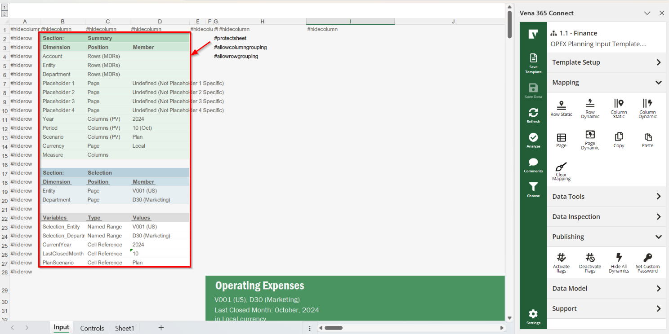

“Selection” Section:

This section is mapped to Section: Selection and contains dynamic page mappings that are to be used as choose (filter) options for your template (defaulted choose options are for Entity and Department selections). You can add other dynamic page mappings as required.

“Variables”:

Variables are specific cells that are used as named ranges and/or cell references within your template. These cells are not mapped. For example, the “Selection_Entity” and “Selection_Department” named ranges reference the dynamic page mappings within the Selection Section. These named ranges are leveraged in the MDR mapping queries for the entity & department dimensions. For example, the department dimension is mapped within the MDRs as bottomlevel(selection_department), so that if the parent “All Departments” is selected, you see a breakdown of each individual department.

Important Note:

Within V365, process variables can simply be refenced via excel formulas. Example: A process variable with the name “CurrentYear” can be referenced within a template by inputting =PVCurrentYear within an excel cell (i.e. prefix “PV” with the name of the process variable).

However, within the desktop add-in, newly added process variables will not update using this logic.
Adding process variables with the desktop are required to be mapped. You cannot map them to the summary section, because these dimensions are already column mapped (via form variables), and a dimension cannot be mapped to two different locations (i.e. cannot have dimension mapped to both “page” and “column” in the same section).

So what?

There are two ways around this:

- If possible, add in process variables to your template using V365 (i.e. a formula with the prefix “PV” and the name of the process variable), refresh and save your template in V365. When you reference a process variable in V365 and refresh, the process variable is updated with backend logic to sync with the desktop add-in so that it will update accordingly when the template is opened via the desktop add-in.
- If only the desktop add-in is available for managing your templates, then map your process variables to a new section (so it does not overlap with dimension mapping in other sections) and reference it.

Note that the latest Foundation Templates are saved in V365, so the process variables that come with the Foundation Package are already synced (and will update accordingly) in both V365 and the Desktop add-in. This important note is really only applicable for when new process variables need to be added.

MDR Expressions
One important concept to understand with this input template is that there are three (3) mapping blocks for each group, each with their own MDR expressions:

- Block B1 for your Direct Input Planning Method Accounts (Input Cells)
- Block B2 for your Driver-Based Planning Method Accounts (Calculation Cells)
- Block B3 for your Other Source Planning Method Accounts (Data Load Cells)
The Planning Method Input Template will help you configure which accounts populate in which blocks. See Planning Method Input Template on how you can set up your account planning methods as either input, driver-based or other source.
Direct Input (Block B1):
The Direct Input MDR will populate all the accounts without the following attributes:
NOT (@ “Planning Method | Driver-Based”)
NOT (@ “Planning Method | Other Source”)
Note: This block (Section: Summary, Block: B1) is also LIDs enabled (with a pre-set LID Template row). You just need to ensure this block is LID-enabled to use it.
Driver-Based (Block B2):
The Driver-Based MDR will populate all the accounts with the following attribute:
@ “Planning Method | Driver-Based”
Note: You can choose and retain a pre-set Driver Logic for this account
Other Source (Block B3):
This MDR will populate all the accounts with the following attribute:
@ “Planning Method | Other Source”
Note: Values are locked, you are not able to plan/edit values on these accounts.

Template Configuration
Groupings

Easily navigate and configure groupings on the fly via input cells. You have up to 10 account categories to map to populate your Operating Expense groupings. Simply input the member name within the yellow input cell, which are each pre-assigned a named range that is referenced in adjacent MDRs. Using the screenshot example below, the member name “Operating Expenses” is inputted for Group1 in cell D40. As such, this is referenced as bottomlevel(“Operating Expenses”) in the adjacent Account MDRs:

- Row 41 for B1 (Input Row)
- Row 42 for B2 (Calculation/Driver-Based Row)
- Row 43 for B3 (Other Source/Data Load Row)

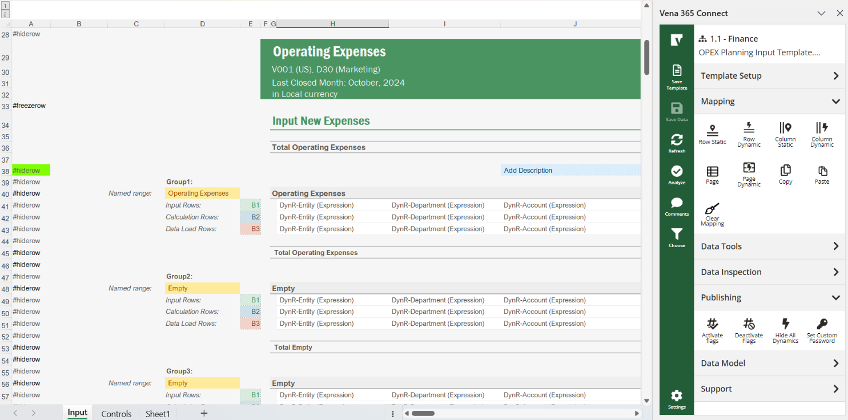

Set Your Fiscal Start Month
The fiscal start months displayed in all Foundation templates and reports are controlled by the date displayed in the first Current Year Actual header.
For example, if you have a fiscal start year beginning in February, your data model would be 1 (Feb), 2 (Mar), 3 (Apr)… and so on. To update your template accordingly to match this fiscal start year, you would update the formula in the first Current Year Actual header from =DATE($D$28,1,1) to =DATE($D$28,2,1) so that the first month displayed in the header would be February. Once updated, all the other monthly headings within the template / report will update accordingly. The screenshot below is for the Corporate Financial Statements Report but is applicable in each individual template/reports (i.e. navigate to the first Current Year Actual header).
Other Template Configurations to Consider
- Enable LIDs (if required)
- Enable MDR input (if required)
- Enable Cascade (if required)

Drivers Set up
You can omit the section below if you do not need to use the driver-based logic or the Other Source MDRs. Otherwise, follow additional Configuration steps in Planning Method Input Template.

Types of Driver:
- $ even spread: this is spreading an $ amount evenly spread across all 12 fiscal periods (amount / 12)
- $ spread by PY: this is spreading a $ amount spread across all the 12 fiscal periods depending on prior year trend.
- % change on PY: this will increase/decrease prior year amount by a % amount.
- 4/4/5 spread: this spread is configured within the input tab. You can easily change the spread to a 4/5/4, 5/4/4 logic by changing the numbers within the Drivers section in the input Tab
- 2 additional Spread Logic Placeholders
- Custom/Pre-set Drivers (% of Revenue, Headcount)
- 2 additional Driver Placeholders

Spread logic: [$ amount] * [spread amount] / [total spread amounts]

- Example 1: evenly spread, it is one (1) for each month (12 months total) = $ amount * 1 / 12
- Example 2: 4/4/5 spread, it is 4-4-5 / 4-4-5 / 4-4-5 / 4-4-5 (total = 52) = $ amount * x / 52 (x being 4 o5 5 depending on the month)
- You can easily build a quarterly spread / active days spread. You also have the option to map this section as an intersection so you could retrieve these numbers if they are saved somewhere else (eg. Number of Contracts, Number of AP days etc.)

Driver Logic: [$ amount or % amount] * Driver (there is no division)

- Example 1: $200 by headcount, 10% of revenue. You can map Headcount / Revenue to retrieve these values
- Example 2: 15% of Salary. You could create a formula to refer to the Salary row in your OPEX Input Template
- You can easily build another Driver and retrieve these amounts by mapping the Driver account (eg. Revenue, Headcount etc.), or simply create a formula to refer a row above (eg. % of Salary)

Enable Drivers
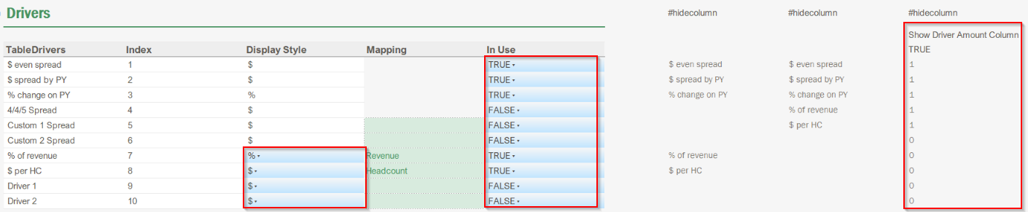
You can decide which Driver you want to use in your template. Your TRUE/FALSE selection will also populate the dropdown list in the Input tab.
Note: If you set them all as FALSE (in case you do not need to use the driver-based logic), it will hide the Planning Method and the Driver amount columns in the Input tab.
For the Drivers only, you can define the Display style as you may want to enter a rate (%) or an amount ($). The value will be entered in the Driver amount column as an input.

Frequently Asked Questions
What if I want to show rows with no data?

The template is using MDR expressions to leverage further functionalities (eg. Zoom-in/out, show rows with no data). In the case you would like to show all the accounts (even the ones with no data), simply go to the MDR expression settings and uncheck “Treat Zeros as Blanks” and “Hide Blank Rows”.

Be careful, as this may drastically impact on the performance of your template (in cases where you have a lot of accounts).
What if I need to add an extra account grouping / category?

Simply insert rows for new grouping and utilize the same logic as previous groupings as required. You can typically do this by copying an existing group and pasting/inserting it underneath. A few things to keep in mind:

- Ensure your newly added grouping is captured within the Subtotal
- Create a new named range for your additional grouping, for the yellow input cell (e.g. Group11).
- Ensure that your account dimension for the three (3) MDRs (B1, B2 and B3) reference this new input cell/grouping.

Revenue and Cost of Revenue Planning Input Template
Important Note: This report is available via Template Studio. Template Studio provides a wizard experience that allows Vena users to easily map templates and reports. Template Studio gives you a starting point for mapping your templates that you can customize later, saving you time and helping you implement Vena faster. Please see How-To: Mapping Standard Vena Templates with Template Studio.
The Revenue and Cost of Revenue Planning Input Template structure is very similar to the OPEX Planning Input Template. This article mainly highlights the main differences.

Functional overview
In the Revenue & Cost of Revenue Planning Input Template, the planning of the Revenue and Cost of Revenue accounts is performed either as direct input or through pre-set driver-based formulas. This reduces the number of manual inputs contributors typically need to do on a direct input template and expedites the forecasting process. The template is pre-configured for you to plan by a specific Entity/Department.

Template Structure
It follows the same architecture as the OPEX Planning Template. The main differences are:

- You have up to 20 account groupings (10 for Revenue, 10 for Cost of Revenue) to populate your final Gross Margin.
- % Revenue Driver is not mapped but replaced by a formula to refer to the Revenue total row in the Input tab.
- Operators are included for each grouping to determine whether the group should be added or subtracted from the total being displayed (eg. Cost of Revenue as negative/positive value respectively will give you Gross Margin = Revenue +/- Cost of Revenue).

Drivers Set up
The main differences are:

- Disabled the Headcount Driver ($ spread by HC) by default. You can easily switch it back to in-use (TRUE) and map the Headcount account.
- Unmapped the Revenue account and replaced it by a formula referencing the Revenue total row.

Planning Method Input Template
This template is considered a “Controls” template, as it is typically managed and configured by power users. It can be found within the Files Library > 1 – Foundation > 1.3 – Foundation Controls.

Functional and Technical overview
This solution is meant to maintain the account planning method logic in the OPEX Planning Input Template and the Revenue and Cost of Revenue Planning Input Template.

Below highlights on the solution logic, which includes 1 input template and an ETL template containing 2 integration channels.

What does it do:

The "Planning Method Input Template" is meant to be used by the client Finance team/Power users to centrally define the planning methods for each individual account within your CoA hierarchy. The possible planning methods are:

- Input
- Driver-Based
- Other Source

Attributes are created using template in combination with the “1 - Planning Method Maintenance” ETL template. The attributes are then used in the MDR expressions of the Driver-based OPEX and Revenue & Cost of Revenue Planning Input Templates to pull the accounts in the right MDR expression on the template. You can read further details on the logic in OPEX Planning Input Template > MDR Expressions.

How to use the Planning Method Input Template:

The Planning Method Input Template is typically defaulted with a choose (filter) options of EBIT, Gross Margin and Operating Expenses accounts; to allow you to decide which accounts you would like to set up the planning method for. These choose option selections align with the accounts that are typically visible on your OPEX Planning Input Template and Revenue and Cost of Revenue Planning Input Template.

Once your choose option is selected, the bottomlevel accounts for the selection will appear in the template, with a blue drop-down option beside each individual account (see screenshot further below).

For direct input planning, leave the drop-down cell blank (i.e. if an account does not have a planning method attribute, then it is assumed to be planned via direct input).
On Data Save, the template will fire an ETL template (“1 - Planning Method Maintenance”) via an ETL trigger, which will dynamically detach/attach attributes to the Account dimension that correspond to the drop-down value saved from the template.

The ETL Template
The “1 - Planning Method Maintenance” ETL template consists of two steps:

- FIN_Planning Method_STEP 1_Detatch Attributes
- FIN_Planning Method_STEP 2_Attach Attributes

Essentially, running this ETL template with the integration channels mentioned above will detach all attributes from the Account dimension with attribute.name LIKE 'Planning Method |%' (as Step 1) and then the attach attributes using calculated mapping ="Planning Method | "&input['value'] within the integration channel (as Step 2), using the intersections values saved within the Planning Method Input Template as a source. See below.

Input Tab Configuration
The Planning Method dropdown selections are determined via Excel Data validation.
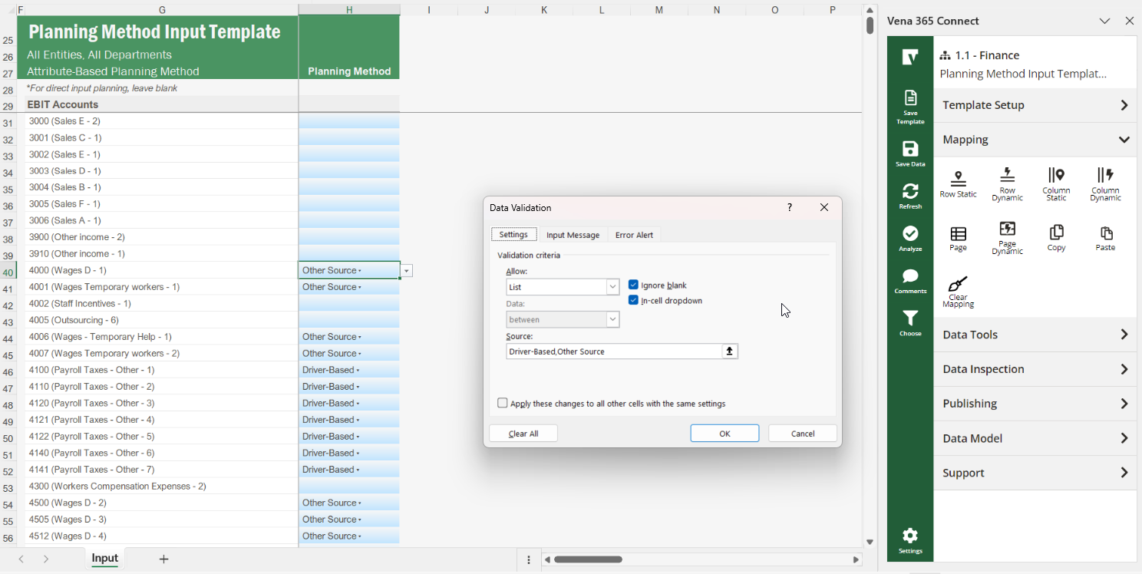
The three (3) preset planning methods are as follows:

Direct Input Planning: End users want to manually enter in plan values for this account within the Revenue & Cost of Revenue and OPEX Planning Input Templates. To select this option for a specific account, leave the adjacent blue drop-down cell blank.
Driver-Based: End users want to leverage the Driver-based method for this account within the Revenue & Cost of Revenue and OPEX Planning Input Templates. To select this option for a specific account, update the adjacent blue drop-down cell to “Driver Based”.

Other Source: Ability to retrieve actual data if on these accounts, but the end-user doesn’t need to provide any plan values for those accounts OR values are coming from a different template (e.g. Workforce Planning Input Template), so they can remain locked. To select this option for a specific account, update the adjacent blue drop-down cell to “Other Source”.

Do not forget to do a data save upon setting up the planning method types for each of your accounts, so that the intersection values save and the “1 - Planning Method Maintenance” ETL template is triggered.

Template Configuration
Within the Selection section, Account: The choose box is pre-set to:

- EBIT
- Gross Margin
- Operating Expenses.

This drives the Dynamic expression in rows to only show the accounts you would like to set the attribute on.

Select one of them from the choose box how to start applying the driver-based logic for the Revenue & Cost of Revenue Planning Input Template AND/OR the OPEX Planning Input Template.

EBIT | This will show you all the bottomlevel accounts underneath EBIT (Revenue & Cost of Revenue, and Operating Expenses). In short, this will exclude Other Income/Expense and Income Tax Expense/Benefit accounts.
Gross Margin | This will show you a list of all the Revenue & Cost of Revenue accounts.
Operating Expenses | This will show you a list of all the OPEX accounts.

Depending on the intersection saved to each account, the FIN_Planning Method_STEP 2_Attach Attributes will create the following attributes to be attached to the associated accounts:

- Planning Method | Driver-Based
- Planning Method | Other Source

If an account does not have a planning method attribute, then it is assumed to be planned via direct input.

Setting up the ETL Trigger

Ensure that the “1 - Planning Method Maintenance” ETL template triggers upon Data Save of the Planning Method Input Template.

Check that an ETL job fired and executed successfully (Modeler > History) and check the leaf accounts on the modeler to make sure the attribute got detached/attached successfully

You can review the steps in the following article: How-To: Setting a SaveData ETL Template ID in Vena Desktop and Vena 365.

Frequently asked questions on the Driver-based logic
What if my ETL job doesn’t detach/attach attributes as expected?

This is a common issue. Make sure to give the right permissions to whoever is going to trigger the ETL job.
Check the data permissions, so this person can save back data in the current slice used to retain the Planning Method Attribute.
Check the application permission: this person should also be able to “update” the Finance cube (attach/detach attributes).
The Planning method of an account is entity/department-specific (or other dimension-specific). What can I do for this?
This is a very rare use-case and will require some custom work. In most instances, users would set the accounts as user inputs to manually enter in values as required, or driver-based, and utilize different driver types across different entity/department selections.
If absolutely required, you will need to refer the specific dimension within Drivers Maintenance Input Template.
Add this dimension within the Selection Section and decide to map it as a choose box (like Entity), or a MEMBER_CELL reference that is driving the dynamic expression in the columns (like Department).
Note that you can only select one dimension in the column mappings, other dimensions are mapped as a Form Variable referring to the member selection.
Rebuild the attribute string adding this extra dimension ( | dim_Additional).
Connect this dimension to the formula mapping, and update the formula to add this extra dimension:
="Planning Method | "&input['value']
&if(input['dim_Entity']="Undefined",""," | "&input['dim_Entity'])
&if(input['dim_Department']="Undefined",""," | "&input['dim_Department'])
&if(input['dim_Additional']="Undefined",""," | "&input['dim_Additional'])
What if I need to add an additional Planning Method (on top of Driver-Based / Other Source)?

You could be in a situation where you need to add an additional Planning method. For example, define a group of accounts using standard Driver Percentages (eg. Payroll Taxes – the % of Salary is pre-set by the Finance team and can’t be changed). You will need to make the following updates:
- Drivers Maintenance Input Template (Input Tab) - Add the additional Planning Method in the Data Validation
- Planning Input Template (Controls tab and Input Tab) - Create an additional Name Range within the Control Tab, and replicate the formula driving the Attribute name In the Input Tab, add an additional MDR expression in each sub account category. Don’t forget to add a NOT() expression in the Direct Input MDR (so you can exclude these accounts driven by the new MDR expression and avoid duplicates).
- Attach Attribute channel - No change required. The formula mapping automatically create the following string Planning Method | PlanningMethodAttribute_value
Can I change the attribute name “Planning Method | “ by something else?
Yes you can. Make sure to update:

- The query in the source used to detach attributes: dimension.name='Account' and attribute.name LIKE Planning Method |%'
- The formula mapping in the Attach Attribute Channel
- The formula in the attribute string (in the Controls tab - Planning Input template) driving the ATTRIBUTE_CELL() in the MDR expressions

Balance Sheet & Cash Flow Planning Input Template

Functional overview
The Balance Sheet and Cash Flow Planning Input Template is a generic “method-based” planning template for which primary purpose is to calculate ending balances on the Balance Sheet (Assets, Liabilities and Equity), based on the client’s Chart of Accounts with the intention of:

- Facilitating the creation of the Cash Flow Statement.
- Saving back Balance Sheet values (to be used in the Corporate Financial Statements report).
- Put together the Indirect Cash Flow Statement (Actuals and Plan).

The following chart shows where this template fits in with the rest of the Foundation solution ecosystem:
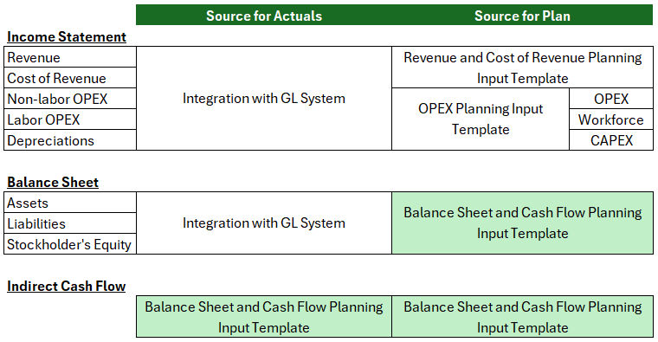
This template will typically be used by the Corporate Finance Team in charge of finalizing and reviewing the consistency of the Corporate Financial Statements and Cash Flow Reports before publishing them to the rest of the organization.

Technical Overview
Before beginning…
To implement this template, you need to understand the mechanics of the Indirect Cash Flow. Please review the following articles before starting:
- Statement of Cash Flow
- Cash Flows Statement​​​​​​​
Detailed Cash calculation with some math:
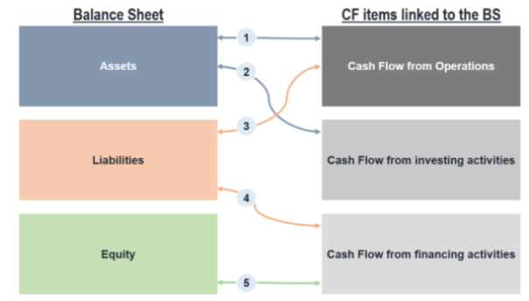
Increases in Cash =
Net Income/(Loss) - other Current Assets + Current Liabilities (Operating)
- Non-Current Assets + Non-Current Liabilities (Investing)
+ Other Equity items - Dividends (Financing)

Template Structure
The template contains 4 tabs:
- A Balance Sheet tab driven by the Controls tab, that contains 2 sections:
  - At the top, a summary view of the Balance Sheet, driven by the bottom section
- Supporting schedules that plan all the balances based on the methods selected in the Controls tab, and that drive the summary view at the top.
- A Cash Flow tab that populates the Indirect Cash Flow actual and plan view based on the Balance Sheet tab.
- A Controls tab that contains all the template’s configuration:
  - Configuration Options
  - Parameters (Income Statement, Balance Sheet, Cash Flow)
  - Workbook Variables & Settings
  - Sections Management (Page mappings for Summary)
  - Date Management (to drive the Date headers)

Mapping
Tab | Section Name | Blocks
Supporting Schedules | Balance Sheet  - Page  Placeholder 1-4 (Undefined)  Currency – Local | B1 – BS Actuals Retrieve  B2 – Plan Save Back  B3 – Plan Retrieve  B4 – IS Actuals and Plan Retrieve  - Columns: Entity (FV), Department (FV), Year (FV), Period (FV), Scenario (FV), Measure (FV, Value)  - Rows: Account (FV)
Cash Flow | CashFlow  - Page  Placeholder 1-4 (Undefined)  Currency – Local | B1 – IS (Non-Cash) Actuals and Plan Retrieve  - Columns: Year (FV), Period (FV), Scenario (FV), Measure (FV, Value)  - Rows: Entity (FV), Department (FV), Account (FV)
Controls | Controls | B1  - Row (static): Account  This will generate an Incomplete Block Warning message. You can dismiss this message
Controls | Selection  - Page  Entity – Bottomlevel(‘All Entities’)  Department – ‘D00’ (if department for Balance sheet) or ‘Undefined’

Template Configuration
Most of the template settings/configurations are done within the Controls Tab.
- Set up the Configuration Options
- Set up the Fiscal Year / Date Headers
- Set up the Planning Method (Regular Planning / Rolling Forecast)

Selection
The template is preset with the following dimensions to be used or not:

Dimensions | Section: Selection
Dimensions | Selection | Name Range (cell reference)
Entity | Bottomlevel ('All Entities') | Selection_Entity
Department | ‘All Departments’ | Selection_Department

The mapping logic depends on whether you are retrieving from or saving values back to the cube.

- For a retrieve, you need to map on a parent or a bottomlevel member.
- For a save back, it must be a bottomlevel member.

Name ranges | Parent Member | Bottomlevel member
Entity | Entity_P | Entity_BL
Department | Department_P | Department_BL (*)

Let’s have a quick review of the mapping logic in each section and blocks:

Section | Block | FV Mapping Used |  | Comment
Balance Sheet (columns) | B1 | Entity_P | Department_P | We want to retrieve BS Actuals
Balance Sheet (columns) | B2 | Entity_BL | Department_BL | We want to save back plan ending balances
Balance Sheet (columns) | B3 | Entity_P | Department_P | We want to retrieve plan ending balances
Balance Sheet (columns) | B4 | Entity_P | Department_P | We want to retrieve IS Actuals and Plan
Cash Flow  (Rows) | B1 - Input | Entity_BL | Department_BL | We want to retain inputs
Cash Flow  (Rows) | B1 - Retrieve | Entity_P | Department_P | We want to retrieve values

To some extent, you will need to review the above name ranges and *FV mappings to make sure they work well with above use cases.

Examples:

Example 1:
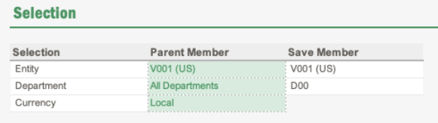
In this example, the client wants to plan for each single entity (Bottomlevel ('All Entities')). To retrieve IS values, we want to use “All departments” as a base for the Department_P member. However, the client is using a predefined department to store their BS values in their GL system (D00).
Example 2:

Selection | Parent Member | Save member
Entity | All US Entities | US Entities - Planned
Department | All Departments | All Department - Planned

In this example, the client wants to plan for all US entities (they have the same functional currency - Local) and he doesn’t have a predefined department to store their planned BS ending balances, so it’s saved on a dummy member.

Note: these dummy members need to roll up into the main hierarchy to appear in the reports.

Mapping Controls

Before starting this step, you need to have:
- A clear understanding of the granularity of items reported in the Cash Flow Statement
- Realized a mapping exercise between the relevant Balance sheet account/group of accounts to be planned at and the cash flow line item where it rolls up to.

The overarching principle of this template is that you should not have to adjust the formulas or redo the mappings in the Balance Sheet and Cash Flow tabs unless your client has a unique way of looking at their balance sheet planning calculations.

The logic that flows through these two tabs is controlled via the following sections of the Controls tab:
- In the Schedules Tab
  - Income Statement Parameters
  - Balance Sheet Parameters
- In the Cash Flow Statement Tab
  - Cash Flow Parameters

Balance Sheet & Schedules Tab
This tab serves 3 main purposes:
- Calculate and save back the planned BS ending balances
- Provide a mapping defined in the Controls tab to roll the cash inflows and out flows into the Cash Flow tab
- Provide a summary view of Actuals and Planned values in the Balance Sheet Statement (to check if this balances)
Balance Sheet Tab Structure
At the top, a summary view of the Balance Sheet, driven by the bottom section. This summary view is not meant to follow the same structure as the one in your Corporate Financial Statement Report. It serves to check if your Balance Sheet still balances. These are exclusively SUMIFS formulas that are pointing to the supporting schedules to retrieve the final calculated ending balance for each Account group below:

BS Category |  | Subcategory | # of Account Groups
Assets | Current Assets | Cash | 1
Assets | Current Assets | Account Receivable | 5
Assets | Current Assets | Inventory | 5
Assets | Current Assets | Other Current Assets | 10
Assets | Non-Current Assets | Gross Fixed Assets | 5
Assets | Non-Current Assets | Accumulated Depreciation | 5
Assets | Non-Current Assets | Other Non-Current Assets | 10
Liabilities | Current Liabilities | Accounts Payable | 5
Liabilities | Current Liabilities | Other Current Liabilities | 10
Liabilities | Long Term Liabilities | Long Term Liabilities | 10
Equity |  | Equity | 5
 |  | Retained Earnings (+ Dividends) | 1 (+1)

The supporting schedules plan all the balances based on the methods selected in the Controls tab for each Account Group filled in the Controls Tab and drives the summary view at the top.

An indexing logic is driving the fields used on each line of the Balance Sheet.

Balance Sheet Tab Configuration

The Balance Sheet Planning Input Template & Cash Flow Statement have been designed in such a way that you can map on a single account as well as a group of accounts.

The main purpose on the Balance Sheet tab is to serve to generate line items on the Cash Flow Statement. You need to discuss with your client to understand:

- Each line item on the the Cash Flow Statement and which account categories on the Balance Sheet flows in those line items
- Understand the planning method of each of these BS Account categories. They might have different methods, so you will need to split the category in two, and sum them afterwards in the Cash Flow tab.

Configure and map your Balance Sheet Accounts

Context on the purpose of each column is below:
- Operator sign: same as in the operator sign in the cube, you will be able to rebuild the roll-up in the template. Eg. Assets - Liability - Equity = 0
- Indexing: you have a certain amount of placeholders. Once you fill a name in the header, this placeholder will be marked as “in use” and it will appear on the top of your Balance Sheet Tab.
- Header: determines what description shows up in the summary view and the header of each supporting schedule in the ‘Balance Sheet’ tab
- Mapping (B1): member to be mapped (in Section: Controls, Block: B1) to retrieve BS Actuals
  - This can be a parent (group) or a bottomlevel member
- Mapping (B2): member to be mapped (in Section: Controls, Block: B1) to save back the calculated planned BS ending balances
  - This has to be a bottomlevel member. You can save it on a defined GL account or a dummy member (named xxxx - Planned).
  - In the case you use a dummy member, this member has to roll-up into the main ‘Balance Sheet’ hierarchy as per below screenshot:
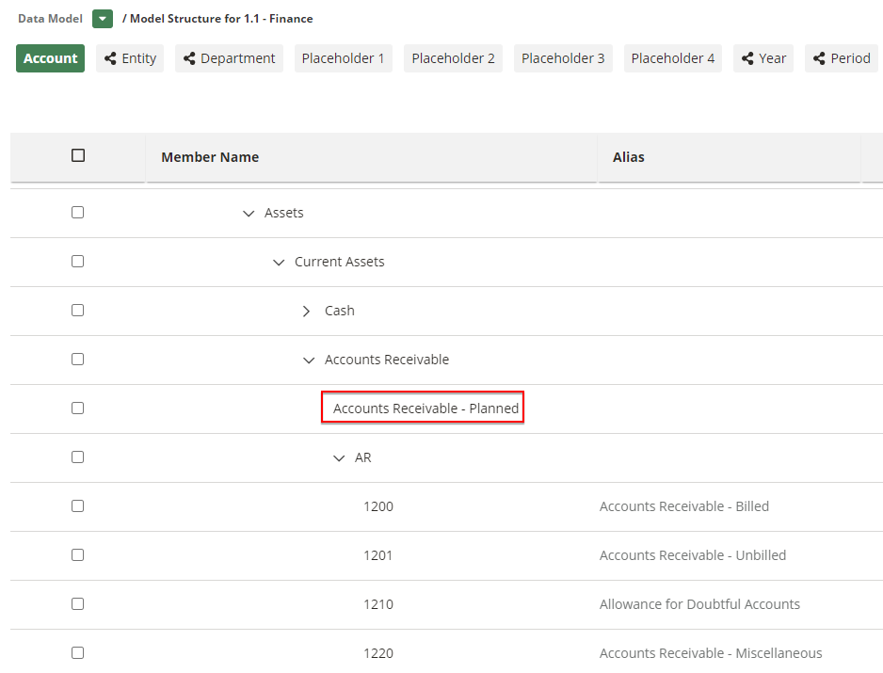

Set the Forecast Method for each Account Group

Each Account Category has pre-defined forecast methods.

Make sure to set the selected forecast method for each account category in use (the ones where you entered a header name)

Depending on the Forecast Method chosen, you will need to associate an account member to save the input or retrieve the data. As per above, you can retain this member by mapping it in Section: Controls, Block: B1.

In the case you need to apply a different forecast method later on, make sure to change the account used in this section.

Note: Each standard method has an input or a retrieve function. Make sure to map a bottomlevel member when you are using the input method.

Note: Any input member is meant to be a dummy outside of the main ‘Balance Sheet’ roll-up because you will be saving activity values, and not ending balances. We recommend you to store these dummy members in a dedicated folder under Other Accounts > Balance Sheet Planning and Cash Flow Statement > eg. Balance Sheet Forecast Method - User Inputs (eg. named xxxx - Input)

Supporting Schedule overview

You will have one defined supporting schedule per Account category pre-set in the Controls tab. Each supporting schedule block has:
​​​​​​​
- a Header: the one you entered in the Controls tab
- an Index (1): once in use (because you entered a header), an index number will be attributed to the account category.
- a Forecast Method (2): this number is driven from the forecast method chosen in the Controls tab
- a Calculation area:
  - For the standard method (input or retrieve) (3)
  - For the custom method (4)
- Ending Balance Amount (5): calculated amount based on the forecast method chosen. This amount will be saved back in the cube. The logic is incremental. You are starting from the opening balance of the month, add up the activity (input or retrieve) to get the final ending balance. Then the same applies for following months.

Note: the hide/show row logic is dependent on:

- the account category in use or not (header)
- the forecast method chosen
Supporting Schedule mapping overview

The *FV in rows are set up to get the member defined in the Controls tab or “Empty”.

 | Action | Block | Member
1 | Retrieve Actuals | B1 | GL account (parent or bottomlevel member)
2 | Save back Activity/Driver Input | B2 | dummy member (bottom level)  Eg. Accounts Receivable - Input  Eg. Days Sales Outstanding
2 | Eg. Accounts Receivable - Input | B3 | dummy member (parent or bottomlevel member)  Eg. Accounts Receivable Activity (From AR template)
3 | Save back Ending Balance | B2 | Eg. Accounts Receivable - Planned

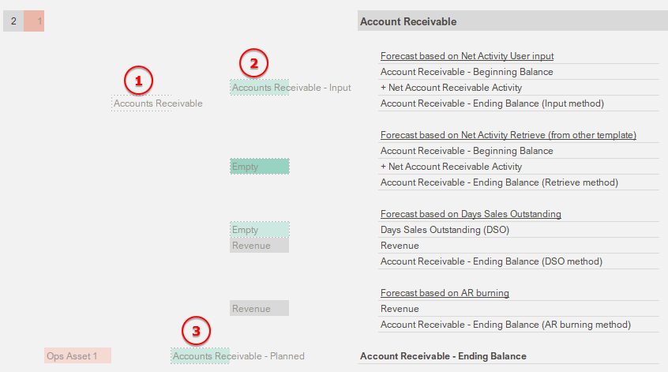

Supporting Schedule for each Forecast Method
- Standard Method: Beginning balance + Net Activity
- Standard Method: Beginning balance + Acquisitions/Issuance - Disposal/Repayment/Buyback
- Custom Method

Each Forecast Method follows its own set up.
- Standard Method: Beginning balance + Net Activity
  - There’s one line to store/retrieve the net activity in the dedicated month.
  - This applies for current Assets and current Liabilities Account categories
  - See screenshot above
- Standard Method: Beginning balance + Acquisitions/Issuance - Disposal/Repayment/Buyback
  - The Net Activity is split between Acquisitions/Disposal (Non-current assets), Issuance/Repayment (Long-Term Debt), Issuance/Buyback (Equity)
  - For these types of account, a second column was added in the Controls tab.
    - If left empty, it will assume that you are using the Net activity logic.
    - If Disposal/Repayment/Buyback is used, then a hide/showrow logic will show the second row, headers will also change to reflect the type.
    - See below screenshots for comparison

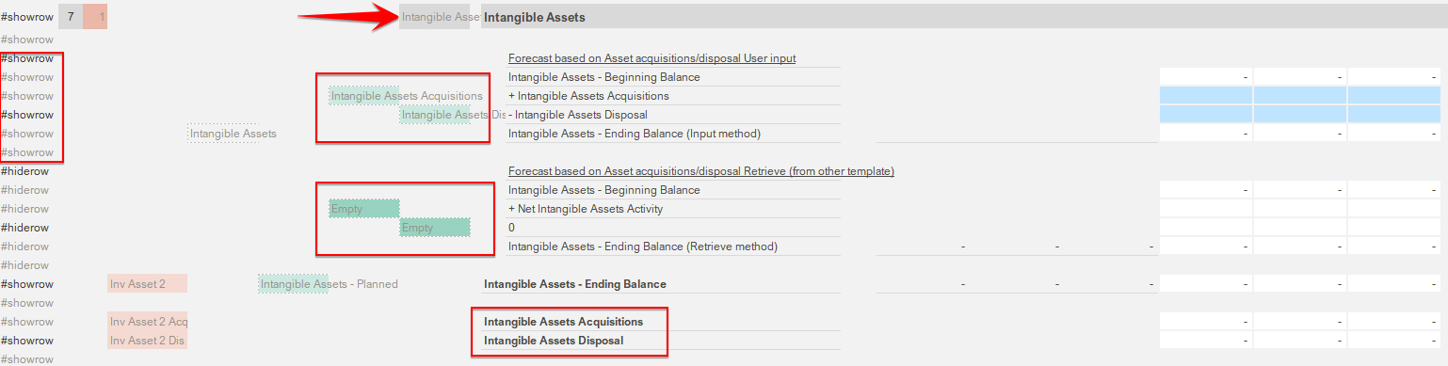

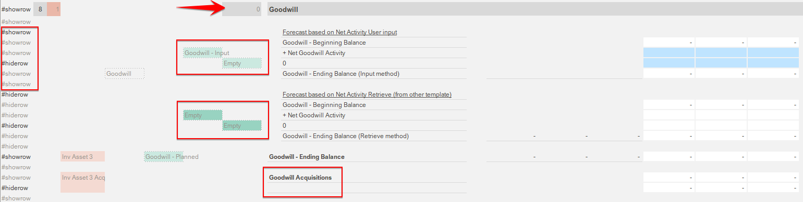

- Custom Methods
  - These custom methods have been designed to cover the following driver-based calculation:
    - Days Sales Outstanding (based on Revenue) for Accounts Receivable
    - AR Burning (based on Revenue) for Accounts Receivable
    - Days Sales of Inventory (based on COGS) for Inventory
    - Days Payable Outstanding (based on COGS) for Accounts Payable
  - Each one of these calculation methods refers to an Income Statement account. These has been preset for you, but you can easily change the referred account by pointing to a different account mapped under the Income Statement Parameters section.

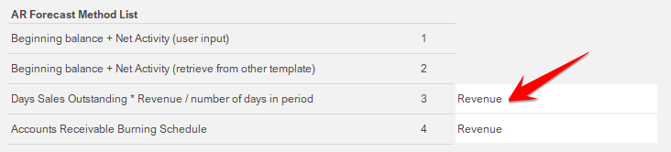

In the Controls tab, make sure to map the GL accounts referring to below categories (Section: Controls, Block: B1)

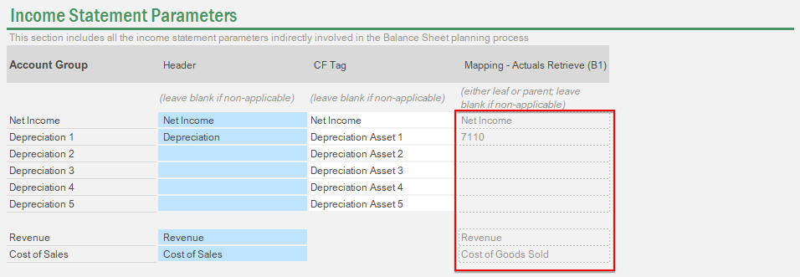

Supporting Schedule for Fixed Assets

The particularity of the Fixed Assets is that you need to report:

- non-cash activities (Depreciations) under Operating activities
- Asset acquisitions/Disposals under Investing activities (change on Fixed Asset Gross value, excluding accumulated depreciation)

You have the ability to plan for up to 5 asset types. Each asset type comes with a placeholder for:

- Gross Fixed Asset Value
- Accumulated Depreciation associated to the fixed asset type

You will need to maintain the relationship between the Accumulated depreciation account (Balance Sheet) and the related Depreciation account (Expense account under Income Statement). This can be updated by referring to the right Depreciation Account under the Income Statement Parameters.

Supporting Schedule for Retained Earnings

Closing Retained Earnings = Opening Retained Earnings + Net Income - Dividends paid

The particularity of this section is that you need to report:

- Net Income under Operating activities
- Dividends paid under Financing activities

You will need to map the appropriate GL accounts relative to:

- Retained Earnings (for Actuals - ending balance)
- Retained Earnings - Planned (to save planned ending balance)
- Make sure that the Driver is set to the right account for Net Income
- Dividends (for Actuals - ending balance)
- Create/map a dummy member to retain planned Cash Dividends paid inputs (activity). This is an input field by default, not a retrieve.

Validate the Balance Sheet Check

At the top of the tab, you have the ability to quickly review if your Balance Sheet balances (Assets = Liability + Equity).

Tying out the actuals portion of the Balance Sheet

- Save template & refresh
- Go in the Balance Sheet tab and make sure the Actual data is flowing in the Summary section at the top
- Use the check (see screenshot above) above the Balance Sheet summary to make sure your balance sheet is in balance. If not, compare line by line with the offline version of the balance sheet provided by your client to find the gap.

Most probable reasons for the gap:

- Some accounts are not entered properly on the controls tab
- Some parent accounts in your ‘Balance Sheet’ roll up on the Account dimension are missing leaf level GL accounts that sit in your unmapped folder
- Your balance sheet roll up on the data model side contains members with an operator accidentally set to “~”
- Some account groupings are missing and you need to add more categories in the controls and the balance sheet tab (if it’s the case, please refer to the “Frequently asked questions” section in Balance Sheet & Cash Flow Planning Input Template
- Your client offline balance sheet was not even tying out in the first place (in which case, just try to match the same gap as your client and notify her/him that there might be something wrong on their end)

Now that your Balance Sheet actuals are tying out, you can move on to the forecast part of your Balance Sheet.

Tying out the plan portion of the Balance Sheet

- First, make sure that your Balance Sheet check is tying out for the Actual portion
- For all the account groups where you specified in the Controls tab that the forecast method is “activity coming from another template”, go in the corresponding supporting schedule and make sure that you see the data flowing in
- For all the account groups where you specified in the Controls tab that the forecast method is “activity as user input”, go in the corresponding supporting schedule, input some data, save data, delete it, refresh and make sure it flows back.
- Make sure you always check that your balance sheet is tying out after the steps above

Cash Flow Statement Tab
This tab serves 2 main purposes:
- Aggregate and report any month-over-month changes (activity) observed on the balance Sheet Accounts on a designated line of the Indirect Cash Flow
- Prepare the Cash Flow Statement (for actuals and planning) using the Indirect Method
Cash Flow Tab Structure

This is an Indirect Cash Flow Statement. The indirect method for the preparation of the statement of cash flows involves the adjustment of Net Income with changes in balance sheet accounts to arrive at the amount of cash generated by operating activities.

Cash Reconciliation |  |  | # of Line Items
Beginning Balance
+ Operating Activities  (Indirect Method) | Net Income |  | 1
+ Operating Activities  (Indirect Method) | Non-cash Expenses | Non-Cash Expenses (from GL) | 5
+ Operating Activities  (Indirect Method) | Non-cash Expenses | Non-Cash Expenses (input) | 5
+ Operating Activities  (Indirect Method) | Non-cash Expenses | Non-Cash Expenses (Depreciations) | 5
+ Operating Activities  (Indirect Method) | Working Capital | Change in Current Assets | 20
+ Operating Activities  (Indirect Method) | Working Capital | Change in Current Liabilities | 15
+ Investing Activities | Change in Non-current Assets |  | 15
+ Investing Activities | Change in Long Term Liabilities |  | 10
+ Financing Activities | Change in Equity (w/o Retained Earnings) |  | 5
+ Financing Activities | Dividends Paid |  | 1
Ending Balance

An indexing logic is driving the line items to be shown and placed over the 3 areas of the Cash Flow Statement (Operating/Investing/Financing Activities)

Cash Flow Tab Configuration

The Cash Flow tab has been built in such a way that you can aggregate many Balance Sheet accounts changes to one single line on your Cash Flow Statement.

The main purpose of this tab is to transcript the account activity (change) to a cash inflow or outflow, and direct these movements to the right section of your statement (operating, investing, financing).

Connect your Balance Sheet to your Cash Flow Statement (CF Tag)

The real exercise is to map the change (Activity) on the Balance Sheet Account Groups to a Cash Flow line item. To do so, go to the Balance Sheet parameters and refer to the line item under from the Cash Flow parameters with a formula:

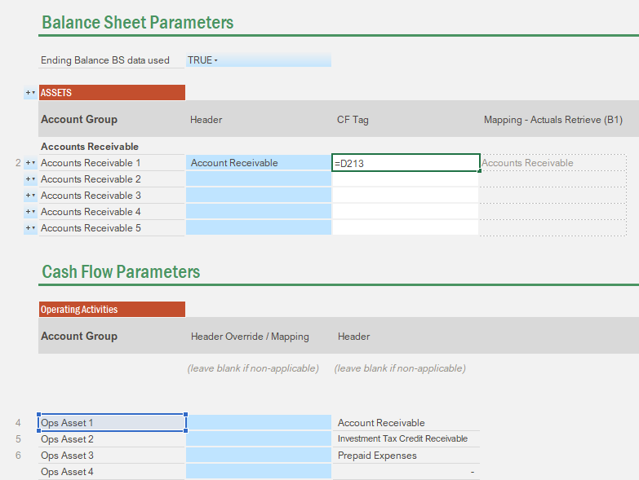

For mapping guidance, see below a cheat sheet on the relationship between Cash Flow and Balance Sheet:

Balance Sheet | Increase impact | Cash Flow
Current Assets | outflow | Operating Activities
Non-Current Assets | outflow | Investing Activities
Current Liabilities | inflow | Operating Activities
Long Term Liabilities | inflow | Financing Activities
Equity | inflow | Financing Activities

Once you have linked all the Balance Sheet Account Groups, you can now set your Cash Flow Statement.

Configure your Cash Flow Statement

The Cash Flow statement has 3 sections:

- Operating Activities
- Investing Activities
- Financing Activities

Configure the Operating Activities

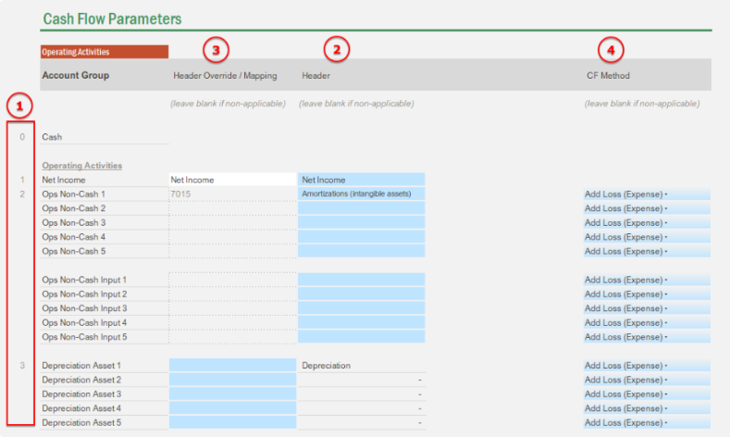

- Indexing: you have a certain amount of placeholders. Once you fill a name in the header, this placeholder will be marked as “in use” and it will appear on your Cash Flow Tab.
- Header: determines what description shows up on each line item in the ‘Cash Flow’ tab.
- Header Override: it gives you the ability to override the prescriptive description coming from the mapping exercise (see below). Mapping: serves to map non-cash items (designated GL account for data retrieve or dummy members for inputs)
- CF Method: this is driving the inflow (add) and outflow (less) logic.

Review below how you can set each line item category under the Operating Activities:

- Net Income
  - Mapping: formula retrieving the account mapped in the Income Statement Parameters
  - Header: Line item description shown in the Cash Flow Statement.

- Non-Cash Items: GL
  - Mapping: map an existing GL account (under Income Statement) to retrieve an activity.
  - Header: Line item description shown in the Cash Flow Statement.
  - CF Method: expense increase (positive value) is added back (gain will be entered as a negative value)

- Non-Cash Items: Inputs
  - Mapping: map a dummy member (for non-cash inputs). The dummy member can be placed under Other Accounts > Balance Sheet Planning and Cash Flow Statement > Cash Flow - User Inputs
  - Header: Line item description shown in the Cash Flow Statement.
  - CF Method: expense increase (positive value) is added back (gain will be entered as a negative value)

- Non Cash Items: Depreciations
  - Header: it will retrieve the header set on the Balance Sheet parameters to be the line item description shown in the Cash Flow Statement.
  - Header Override: you can override the description pulled from the Balance Sheet parameters
  - CF Method: expense increase (positive value) is added back (gain will be entered as a negative value)

- Operating activities (assets)
  - Header: it will retrieve the header set on the Balance Sheet parameters to be the line item description shown in the Cash Flow Statement. It will be shown as “- Change …” (because of the CF method selected below)
  - Header Override: you can override the description pulled from the Balance Sheet parameters
  - CF Method: default to Less the change (increase) since it’s an asset account

- Operating activities (liabilities)
  - Header: it will retrieve the header set on the Balance Sheet parameters to be the line item description shown in the Cash Flow Statement. It will be shown as “+ Change …” (because of the CF method selected below)
  - Header Override: you can override the description pulled from the Balance Sheet parameters
  - CF Method: default to Add the change (increase) since it’s a liability account

Common non-cash items are the following:
- Depreciation + Amortization
- Losses and gains on disposal of non-current assets
- Losses and gains on disposal of investments (both realized and unrealized)
- Losses and gains on fair market value (mark-to-market) adjustments
- Losses and gains on debt retirement
- Impairment losses on non-current assets
  - Property, Plant, and Equipment
  - Investments
  - Goodwill
- Pension adjustments and gains/losses on pensions
- Share based (stock compensation)
- Deferred income taxes (outside those recognized in working capital)
- Restructuring provisions
- Provisions and contingencies for future losses

Configure the Investing Activities
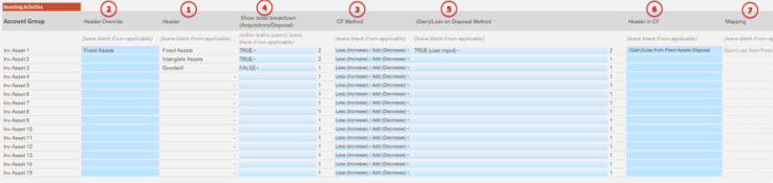

- Header: it will retrieve the header set on the Balance Sheet parameters to be the line item description shown in the Cash Flow Statement. It will be shown as “- Change …” (because of the CF method selected below)
- Header Override: you can override the description pulled from the Balance Sheet parameters
- CF Method: default to Less the change (increase) since it’s an asset account
- Show Details: It will split the Net Activity into Acquisition (increase) / Disposal (decrease). If set to true, the Net activity line will be hidden, acquisition/Disposal line items will be shown as:
  - “- [Header] Acquisitions” (because of the CF method selected above)
  - “+ [Header] Disposal” (because of the CF method selected above)
- (Gain)/Loss on Disposal: there’s a particularity on the Disposal line item where we need to exclude any gain/loss on the disposal from the Investing Activities section, so they can be reported in the Operating Activities section.
  - If left blank or FALSE, the gain/loss item for the associated Investing Activity line item won’t be shown
  - If TRUE (user input), only the top row will be shown (input cells)
  - if TRUE (from other template), only the second row will be shown (locked cells)

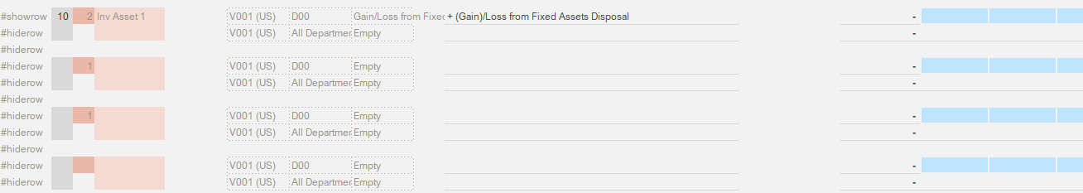

- Header in CF: Line item description shown in the Cash Flow Statement. It will be shown as “+ [Header]” (because of the CF method selected above)
  - With current set up, any “gains” on Disposal should be inputted as a negative value, and losses as a positive value.
- Mapping: if you selected TRUE in step 5 above, you need to indicate the dummy member to retrieve/save data back on. The dummy member can be placed under Other Accounts > Balance Sheet Planning and Cash Flow Statement > Cash Flow - User Inputs

Configure the Financing Activities

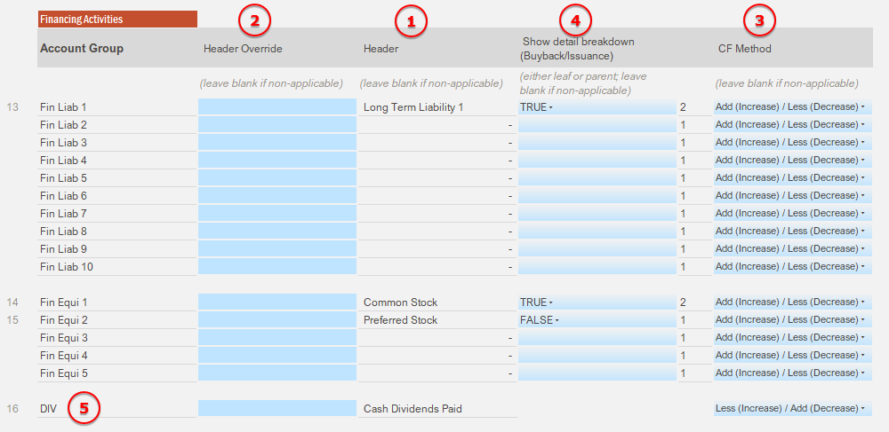

- Header: it will retrieve the header set on the Balance Sheet parameters to be the line item description shown in the Cash Flow Statement. It will be shown as “+ Change …” (because of the CF method selected below)
- Header Override: you can override the description pulled from the Balance Sheet parameters
- CF Method: default to Add the change (increase) since it’s an liability/equity account
- Show Details: It will split the Net Activity into Issuance (increase) / Repayment (decrease for liability) or Buyback (decrease for equity) . If set to true, the Net activity line will be hidden, Issuance/Repayment or Buyback line items will be shown as:
  - “+ [Header] Issuance” (because of the CF method selected above)
  - “- [Header] Repayment” or “- [Header] Buyback” (because of the CF method selected above)
- Cash Dividends Paid are set by default as an input field (activity) under the Retained Earnings Supporting Schedule in the Balance Sheet tab. Make sure that “Cash Dividends Paid” is linked to the “DIV” line item in the Cash Flow

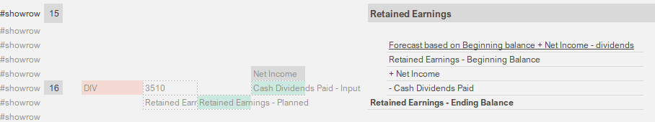

Validate the Cash Flow Check

At the top of the tab, you have the ability to quickly review if your Cash Flow ending balance on the Cash Flow tab matches the calculated Cash ending balance in the Balance Sheet tab (Liability + Equity – Assets (excluding the Cash line)).

Tying out the plan portion of the CF statement

It’s actually easier to tie out your Cash Flow plan first on this tab before tying out your actuals: there is simply less data on the plan initially, which makes the troubleshooting an incremental exercise, as opposed to trying to figure out the origin of a gap that is actually a mix of multiple factors, like it’s often the case when you try to tie out the actuals.

In order to tie out your plan, follow those steps:

- Make sure all your forecast input fields on the Balance sheet tab are empty
- Go into your Revenue & COGS Planning Input Template and OPEX Planning Input Template to generate planned data on your Income Statement that you can retrieve in this template (at the bottom of the Balance Sheet tab)
- Go back to the CF tab; in the plan section, you should only see your Net Income flowing on the top row. If not, make sure that you correctly linked the Net income to your Cash Flow line item:

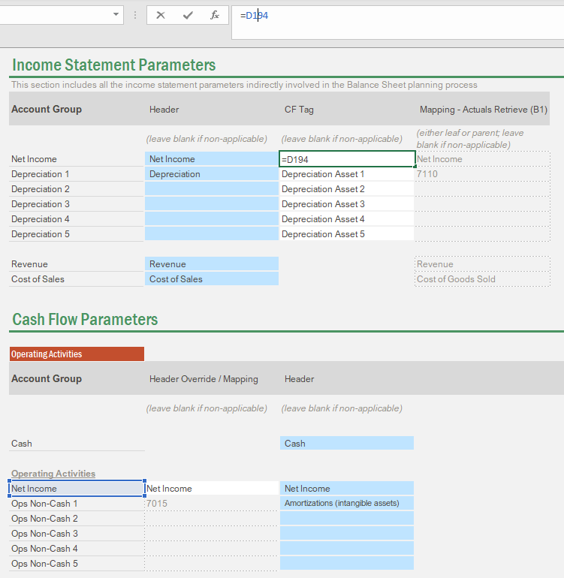

At this point, is the cash tying out ? If not, don’t even go any further, something is wrong and you need to troubleshoot

Most probable reasons for the gap:

- Your Balance Sheet is not tying out. Make sure assets = liabilities + equity (see consistency check under the Balance Sheet tab)
- The consistency check for the cash is wrong. Go back to the Balance Sheet tab, and simply validate the planned cash calculation to be “Liabilities + Equity - Assets (excluding cash)). In case you have manually added new assets, liabilities or equity categories in the Summary view of the Balance Sheet tab, make sure the check formula is picking them up!

- Now that your cash is balancing out, let’s re-inject progressively some plan inputs in the cash flow statement and see if it still ties out. Start by inputting some AR plan movement back in the Balance Sheet tab (under the Account Receivable supporting schedule), then go back to the CF tab… is the cash still tying out? If not, there is probably something wrong with your AR logic

- Reproduce those steps for every supporting schedule on your balance sheet tab, and in between every input, make sure you check the cash balance consistency.

Tying out the actual portion of the CF statement

At this point your cash flow statement should be consistent on the plan side. The good news is that the formulas that make up the cash flow statement referring to the Balance Sheet are the exact same between the actuals and plan periods. So it means that if your plan is tying out already, you should also be pretty close to tying out your actuals.

To tie out your actuals, follow those steps:

At this point, if you see a gap on the CF check for the actuals, the most probable reasons for this gap should be:

- Your balance sheet is not tying out on the actuals portion. If that’s the case, your effort should go towards fixing the balance sheet gap first before proceeding with this step.
- If you still see a gap, it might be because you have modified the structure of the Balance Sheet summary to accommodate for other Assets, Liabilities or Equity categories that where not part of the initial file structure, and you have not added back new lines in the Cash Flow Statement to account for those new categories. Make sure to review that any Balance Sheet account category is tagged to a Cash Flow line item (review above steps).

Frequently Asked Questions
How to troubleshoot Cash Flow check discrepancy?

Considering that there are no technical disconnects within the Vena template and all the necessary mappings are checked off, refer to the below document that helps to explain one of the reasons why we encounter cash flow check discrepancies in “Balance Sheet and Cash Flow Planning Input Template”.
The cash flow check issue is sometimes related to how the client is recording Amortization & Depreciation expense and Accumulated Depreciation as shown:

Cash Flow Check Discrepancy in the Cash Flow Statement Balance Sheet and Cash Flow Planning Input Template

Careful, this logic also applies for the plan save back (YTD - planned) to be retrieved in the Balance Sheet tab in the Corporate Financial Statements.

There are underlined issues to consider with loading BS accounts as activities such as FX conversion, the ETL package etc. Please make sure to discuss this requirement with your Solution Architect.

Step 5 (Foundation) - ETL Packages
This set of articles will help you deploy the ETL for Foundation projects (Finance cube).

It can also be used for Custom Projects if you have received the Foundation Package Migration (including the Finance cube). All the Vena Tables and VenaQL are based on the Finance cube. If you haven’t received the finance cube to start with you can still review and replicate the logic from the solutionpackagedemo.com tenant.

Covered Requirements
The objective of this document is to describe 3 ETL methods that are part of the Foundation Package. By creating and leveraging a standard ETL method we want to improve Time to Value, reduce user errors and leverage best practices (Naming conventions, VenaQL and transformation logic)

Business Requirements

Easily load GL (P&L and Balance Sheet) data to the Finance cube
Easily load and access transaction data from the Foundation templates and Reports

Functional Requirements

- Be autonomous (No SQL that requires an ETL resource) (All Methods)
- ETL logic to automatically sign flip Revenue, Liability and Equity Accounts (All Methods)
- Easily load data to my data model and create a transaction table (Simple and Advanced Methods)
- Perform basic aggregation or standard channel transformation logic to a data file (Simple and Advanced Methods)
- I want the ETL logic to automatically create the ending balances for balance sheet accounts (Advanced Method)

Decision Tree

As covered above, you may different functional requirement. The decision tree below will help you to define which Foundation ETL Package is best suited to your use case:

Question | Answer | Deployment Guide | Required Extracts
1) Do I require to build a Drill through table for Transactions | No | Foundation Data Load - Direct Method | GL Summary  (IS activity and BS ending balances)
 | Yes, Go to question 2.
2) Can the client provide ending balances for BS accounts | Yes | Foundation Data Load - Simple Method | GL Transactions  (for both BS and IS)  BS Ending Balance  (From a Balance Sheet Statement)
2) Can the client provide ending balances for BS accounts | No | Foundation Data Load - Advanced Method | GL Transactions  (for both BS and IS)  BS Beginning Balance

The simple Method is the most commonly used, and preferred method across Foundation implementations.

Important Note: As part of Foundation v. 1.2.2 updates - anything associated with the “Simple Method” has been removed from the Foundation Package – as it is now encouraged to leverage QuickStart where applicable. When leveraging quick start, the “simple method” integrations & the ETL template are auto generated and should be leveraged accordingly.

Data Extraction
As for most implementations, it is the client’s responsibility to extract data from their GL/ERP system as described in the Description of Services (DOS).

Note: The current Vena connectors are with Sage Intacct, Netsuite, Quickbooks Online and Salesforce (includes Financial Force). The DOS should explicitly mention that we are using the connectors.

Unless we are using a direct connector the report provided by the client needs to be in a CSV, PSV or TDF format. This report can contain an unlimited number of columns with no specific ordering requirements as long as it contain the following mandatory columns:

- Account #
- Entity #
- Department #
- Year
- Period
- Value
- If required, you have a clear understanding of the transaction drill-through columns from your client

Additional note: Similar to other data loads if you want to load the headers make sure they all contain an “_” in front of them.

Foundation Data Load - Direct Method

Solution Highlights
- This method facilitates the GL data load for both BS and IS accounts.
- BS values are loaded as ending balances (summary level).
- IS values are loaded as monthly activity (summary level).
- Liability, Equity and Revenue accounts (credit accounts) are getting the sign flipped based on the first digit of the GL account number (2,3 or 4).
- No VenaQL is being used in this method

It assumes the following:

- Balance Sheet values are provided as ending balances in the CSV extract
- Income Statement values are provided as monthly activity in the CSV extract
- The account naming convention facilitates the identification of the credit accounts from debit accounts (for the sign flip logic).

Integration Structure

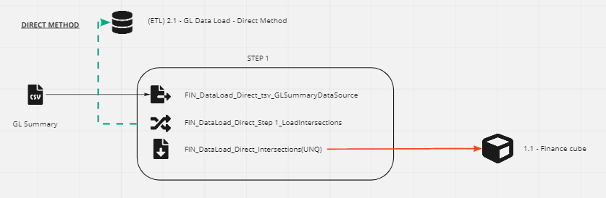

Step | Components | Type | Description
1 | Load BS (ending balances) and IS (monthly activity) data to the Finance cube  Flipping the sign on credit accounts
1 | FIN_DataLoad_Direct_tsv_GLSummaryDataSource | Source | Vena Table holding client BS Ending Balances and IS monthly activities
1 | FIN_DataLoad_Direct_Step 1_LoadIntersections | Channel | Sign flip on Liability, Equity and Revenue accounts (starting by 2, 3 or 4)
1 | FIN_DataLoad_Direct_Intersections(UNQ) | Destination | Intersection Load to Finance cube  AGGREG: Unique  CLEAR: Clear slice on ‘Balance Sheet’ accounts & ‘Net Income’ accounts + dimensions Year / Period / Scenario /Currency / Measure

Adjusting Step 1 Channel

- Create a new Vena Table with client GL Summary file following the steps from Generate and replace a Vena Table Source
- You will need to replace the Vena Table Source: FIN_DataLoad_Direct_tsv_GLSummaryDataSource with the new Vena Table.
- Navigate to and open the channel: FIN_DataLoad_Direct_Step 1_LoadIntersections
- Validate that all the fields are correctly mapped
- Validate the sign flip logic on the credit accounts. Review the formula mapping flipping values on Liability, Equity and Revenue accounts (starting by 2, 3 or 4).

Setting the Direct Method ETL Template

- Create a new ETL Template (Data Modeler > ETL > Templates > + Add Template)
- You can name the ETL Template “2 - GL Data Load”
- Set the Vena Table and the integration channel as per below screenshot

Note: When setting the Vena Table, you do not need to set a clear slice so the table gets regenerated at every load.

Testing the Direct Method ETL Template
If all of the above steps are configured correctly, you should be able to run the ETL Job:

- Upload the following files (for one defined period):
  - GL Summary
- Run the ETL Template
- Review the Status of the job and make sure it gets completed. Spot check the details in the History tab to review the data being loaded (and validate if data gets properly cleared from the cube if any)
- QA the following:
  - Data clearing: upload a different data set and see how it gets updated in:
    - intersections / values in the templates and reports
  - Review the values in the templates & reports for a few periods.

Foundation Data Load - Simple Method

Solution Highlights
- This method facilitates the GL data load and the creation of a Drill Table for both BS and IS accounts.
- BS values are loaded as ending balances (summary level).
- IS transactions are getting aggregated from the GL Transactions extract to a monthly activity (summary level).
- Liability, Equity and Revenue accounts (credit accounts) are getting the sign flipped based on the first digit of the GL account number (2,3 or 4).
- No VenaQL is being used in this method
- Accommodate for up to 30 Transaction fields (on top of the compulsory fields for dimensions and value). More fields can be added, you will just need to revise the staging table.
- You will be able to see Transactions making up the monthly change on the BS accounts & period activity on the IS accounts. (If drill on a BS ending balance in a report, only the transactions making up the monthly change will appear)

It assumes the following:

- Balance Sheet values are provided as ending balances in the CSV extract
- The account naming convention facilitates the identification of the credit accounts from debit accounts (for the sign flip logic).
- Transactions file contains both IS and BS transactions
- Drill will be enabled on BS and IS accounts.
- The client doesn’t need to reconcile BS ending balances with the drill on transactions. You will only be able to see Transactions occurring in the drill period (activity) on BS accounts.

Important Note

As part of Foundation v. 1.2.2 updates - anything associated with the “Simple Method” has been removed from the Foundation Package – as it is now encouraged to leverage QuickStart where applicable. When leveraging quick start, the “simple method” integrations & the ETL template are auto generated and should be leveraged accordingly.

The previous article outlining all the old “simple method” assets were archived accordingly.

Foundation Data Load - Advanced Method

Solution Highlights
- This method facilitates the GL data load and the creation of a Drill Table for both BS and IS accounts.
- BS transactions are getting aggregated from the GL Transactions extract with their respective opening balance data to an ending balance (summary level).
- IS transactions are getting aggregated from the GL Transactions extract to a monthly activity (summary level).
- Liability, Equity and Revenue accounts (credit accounts) are getting the sign flipped based on the first digit of the GL account number (2,3 or 4).
- VenaQL is being used in this method
- Accommodate for up to 30 Transaction fields (on top of the compulsory fields for dimensions and value). More fields can be added, you will just need to revise the staging table.
- You will be able to see Transactions making up the monthly change on the BS accounts & period activity on the IS accounts. (If drill on a BS ending balance in a report, only the transactions making up the monthly change will appear)

It assumes the following:

- The account naming convention facilitates the identification of the credit accounts from debit accounts (for the sign flip logic).
- Transactions file contains both IS and BS transactions
- Drill will be enabled on BS and IS accounts
- The client doesn’t need to reconcile BS ending balances with the drill on transactions. You will only be able to see Transactions occurring in the drill period (activity) on BS accounts.

Integration Structure
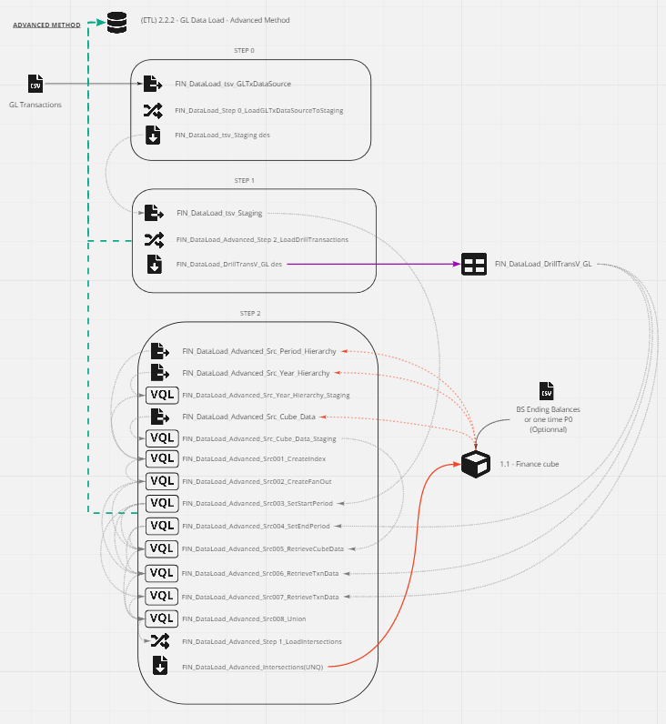
Advanced Method Channels Overview

Step | Components | Type | Description
0 | Map client GL Transactions to a pre-configured staging table  Flipping the sign on credit accounts
0 | FIN_DataLoad_tsv_GLTxDataSource | Source | Vena Table holding client GL Transactions  CLEAR: no clear slice so it gets regenerated at every load
0 | FIN_DataLoad_Step 0_LoadGLTxDataSourceToStaging | Channel | Sign flip on Liability, Equity and Revenue accounts (starting by 2, 3 or 4)
0 | FIN_DataLoad_tsv_Staging des | Destination | Pre-configured staging table from a Vena Table. It holds the Finance cube dimensions and up to 30 transaction fields.  CLEAR: no clear slice so it gets regenerated at every channel run)
1 | Map the pre-configured staging table to client Drill Transaction Table
1 | FIN_DataLoad_tsv_Staging | Source | Pre-configured staging table in Step 0 (with values already flipped)
1 | FIN_DataLoad_Advanced_Step 1_LoadDrillTransactions | Channel | No transformation (only direct mapping)
1 | FIN_DataLoad_DrillTransV_GL des | Destination | Drill table from a Vena Table. It holds the Finance cube dimensions and required client’s transaction fields.  CLEAR: Clear on dimensions Year / Period  You can also clear on the Transaction Date field (in addition to Year/Period dimension) in case you are doing daily loads. The file should contain all the transactions of the day/period loaded.
2 | Aggregate BS Transactions and load BS data to the Finance Cube (ending balance)  Aggregate IS Transactions and load IS data to the Finance Cube (monthly activity)
2 | FIN_DataLoad_Advanced_Src_Period_Hierarchy | Source | Hierarchy export of all periods in 'Full Year’ roll-up
2 | FIN_DataLoad_Advanced_Src_Year_Hierarchy | Source | Hierarchy export of all years in 'All Years’ roll-up
2 | FIN_DataLoad_Advanced_Src_Year_Hierarchy_Staging | VenaQL | Adding one prior year for the fan out logic to include one-time beginning balance P0.
2 | FIN_DataLoad_Advanced_Src_Cube_Data | Source | Export all Actuals under ‘Balance Sheet’ accounts (includes period ending balances and P0 if any)
2 | FIN_DataLoad_Advanced_Src_Cube_Data_Staging | VenaQL | Replace data on P0 - YEAR to period 12 - YEAR-1  P0 MUST be in one unique year (start year for loading transactions). If you already have loaded ending balances on the opening period (eg. period 12 - 2019) you do NOT need to load data in P0.
2 | FIN_DataLoad_Advanced_Src001_CreateIndex | VenaQL | Create an index with all combinations of period and years (with addition of one prior year identified in FIN_DataLoad_Advanced_Src_Year_Hierarchy_Staging)
2 | FIN_DataLoad_Advanced_Src002_CreateFanOut | VenaQL | Create an index that facilitates rolling one period to all subsequent periods.
2 | FIN_DataLoad_Advanced_Src003_SetStartPeriod | VenaQL | Identify the period prior the first period contained in the Transaction file upload (FIN_DataLoad_tsv_Staging)
2 | FIN_DataLoad_Advanced_Src004_SetEndPeriod | VenaQL | Identify the last period contained in the Drill Transaction Table (FIN_DataLoad_DrillTransV_GL)
2 | FIN_DataLoad_Advanced_Src005_RetrieveCubeData | VenaQL | Filter data retrieved in FIN_DataLoad_Advanced_Src_Cube_Data_Staging to select the period from Src_003 (period prior the start period load)
2 | FIN_DataLoad_Advanced_Src006_RetrieveTxnData | VenaQL | Duplicate the transactions in FIN_DataLoad_tsv_Staging using the fan out logic
2 | FIN_DataLoad_Advanced_Src007_RetrieveTxnData | VenaQL | Leave the transactions in FIN_DataLoad_tsv_Staging as is
2 | FIN_DataLoad_Advanced_Src008_Union | VenaQL | Union of:  Src005  Src006 - filter on BS accounts only  Src007 - filter on non BS accounts only (IS)  + value aggregation.  Aggregation done in VenaQL and not in the destination since the job will generate two records in the drill saves.  By default, this step is filtered to pick up accounts beginning with 1,2, and 3. If you have GL Accounts that start with a different digit, they need to be added to the WHERE clause. You can review our Foundation Data Load - General FAQ.
2 | FIN_DataLoad_Advanced_Step 2_LoadIntersections | Channel | No transformation (only direct mapping)
2 | FIN_DataLoad_Advanced_Intersections(UNQ) | Destination | Intersection Load to Finance cube  AGGREG: Unique  CLEAR: Clear slice on ‘Balance Sheet’ accounts & ‘Net Income’ accounts + dimensions Year / Period / Scenario /Currency / Measure

Setting the Advanced Method Channels
Adjusting Step 0 Channel

- Create a new Vena Table with client GL Transaction file following the steps from Generate and replace a Vena Table Source
- You will need to replace the Vena Table Source: FIN_DataLoad_tsv_GLTxDataSource with the new Vena Table.
- Navigate to and open the channel: FIN_DataLoad_Step 0_LoadGLTxDataSourceToStaging
- Validate that all the fields are correctly mapped to the Pre-configured Vena Table (FIN_DataLoad_tsv_Staging des).
- Validate the sign flip logic. Review the formula mapping flipping values on Liability, Equity and Revenue accounts (starting by 2, 3 or 4).

Adjusting Step 1 Channel

- Make sure to adapt the Drill Through table to client’s requirements (columns order, transaction details to be shown etc.). We recommend to NOT create a new table but use the current one. The drill capability is set to this table in the Foundation templates and reports.

Note: You can rename the source FIN_DataLoad_DrillTransV_GL (Table name shown in the templates and reports) - and eventually the associated destination to keep it consistent with naming best practices.

Note: If you decide to create a new table, make sure to:

- Reset the Drill Table in your templates and reports
- Create the equivalent destination table with the following clear slice settings, and replace the destination in the channel
- Navigate to and open the channel: FIN_DataLoad_Advanced_Step 1_LoadDrillTransactions
- Validate that all the fields are correctly mapped

Adjusting Step 2 Channel

- Navigate to and open the channel: FIN_DataLoad_Advanced_Step 2_LoadIntersections
- Review the VenaQL codes and spot check any column addition, or dimension name change (see below warning)
- Validate that all the fields are correctly mapped

Important note on VenaQL:
If you have updated the dimensions names in the data model you will also need to update them in the VenaQL source as they are hard coded in the code. Go through each source and replace the old dimension name with the new one (keep the quotes). This is temporary and there is a ticket opened for it.

Setting the Advanced Method ETL Template
- Create a new ETL Template (Data Modeler > ETL > Templates > + Add Template)
- You can name the ETL Template “2 - GL Data Load”
- Set the Vena Tables and the integration channels as per below screenshot

Note: When setting the Vena Tables, you do not need to set a clear slice so the tables get regenerated at every load.

Testing the Advanced Method ETL Template
If all of the above steps are configured correctly, you should be able to run the ETL Job.

- Upload the following files (for one defined period):
  - GL Transactions
  - Ensure you have the beginning balances P0 in the cube
- Run the ETL Template
- Review the Status of the job and make sure it gets completed. Spot check the details in the History tab to review the data being loaded (and validate if data gets properly cleared from the cube if any)
- QA the following:
  - Data clearing: upload a different data set and see how it gets updated in:
    - the Drill Table
    - intersections / values in the templates and reports
  - Drill Table functionality (are you able to drill on this table) and validate the layout
    - when drilling on BS accounts, are you able to reconcile to the monthly change (eg. P2 transactions = P2 - P1 ending balance)
    - when drilling on IS accounts, are you able to reconcile the monthly activity (eg. P2 transactions = P2 monthly activity)
  - Review the values in the templates & reports for a few periods

How to get the Opening Balance?

What is an Opening Balance?
As you are aware, Balance Sheet GL accounts are constituted of balances built over time. Unfortunately some source systems will only extract current month activity for an account so the balances will have to be calculated.

In order to calculate balances, we need the opening balance of the first loaded period with transactions.

How to get the Opening Balance in the cube?
Question | Answer | Solution
Are you loading any historical years as ending balances (not using transactions)? | Yes | You do not need to provide P0. The advanced method is smart enough to pick prior period ending balance.
 | No | You need to provide a one-time P0 as a starting point for your transactions to aggregate.
2. Can the client input these balances? | Yes [PREFERRED] | Input the beginning balances via an Input Template
2. Can the client input these balances? | No | Load the beginning balances via a direct data load

What to do next?
Pre-requisites:
Your cube should have a member called P0 under “All Periods”.
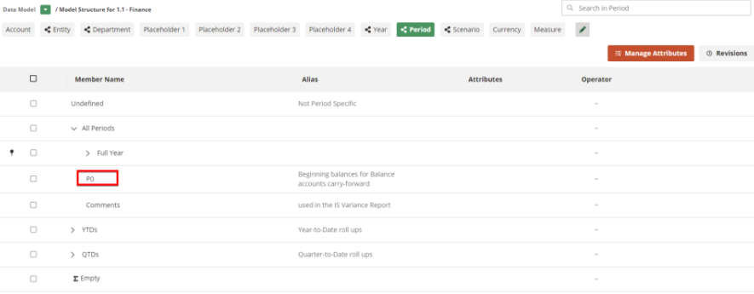
The Advanced ETL method assumes that your customer will have:

- P0 provided for one year (unique). It has to be on the year when you start uploading your first transaction.
- OR have ending balances loaded in the cube on the period prior to your first transaction

Examples:

- If you start loading Transactions as of Jan 2020 (Period 1 - Year 2020), you need to have:
- Dec 2019 Ending balances loaded in P0 – 2020
- OR ending balances loaded in Period 12 (Dec), Year 2019

- If you start loading Transactions as of March 2021 (Period 3 - Year 2021), you need to have:
- Feb 2021 Ending balances loaded in P0 - 2021
- OR ending balances loaded in Period 2 (Feb), Year 2021

Depending on the solution you choose to go with, follow the respective steps:

Client is okay to input beginning balances from an Input Template

- Go to the Foundation Files Library > 1 - Foundation / 1.3 - Foundation Controls / Beginning Balance Input Template.xlsx
- This template is a simple input template mapped on the bottom level of “Balance Sheet” accounts.
- Make sure P0 balances (ie. check your R/E in case this is not coming with the GL load).
- Select the (fiscal) year for which you’d like to input the beginning balance for

Client wants to use a data load
- You can leverage the BS ending balances data specs.
- You can create a single channel or use the channels from the Foundation Data Load - Direct Method.
- Make sure to update the data spec or the channel mapping to set the Period to ‘P0’ (and replicate the clear slice logic from the Direct Method - step 1)

Foundation Data Load - General FAQ
Find below the top frequently asked question when implementing the packaged ETL.

Can I only receive the channels (to use for a custom implementation or just to avoid rebuilding the channels)?

We will require you to have the Finance cube beforehand. All the Vena Tables, sources and destinations are connected to this cube. You won’t be able to deploy the package if the channels can’t reconnect to this cube.

- You don’t have a cube that has the ID 651628815408562176 in the tenant → request the channels with the Finance cube, then you can easily reconnect the sources to your own Finance cube. See next question for further details.
- You already have a cube with the ID 651628815408562176 in the tenant → request the channels without the Finance cube.

To request the migration of the ETL package, use the Solution Package Migration Request Form

What if I am using a different cube than the original Finance cube from Foundation?

If you change:
- dimension name
  - If you are using the Advanced method, make sure to revise the name of the dimension in the VenaQL codes
- dimension order
  - you will need to review the mappings in each channel to make sure that they point to the right dimension (and the default value mapping if any)
  - review the clear slice by dimension settings in the Vena destinations
- 'Account' dimension name and/or ‘Balance Sheet', ‘Net Income’ member names
  - review the clear slice expression set in the Vena destinations (for intersection load)

If you add/delete:
- a dimension
  - you will need to review the mappings in each channel to make sure that they point to the right dimension

What if client extract does not provide a member for each dimension ?

If the destination returns a ‘blank’ member on the intersection load, the job will fail. You can use the following options:

- the extract doesn’t include the dimension → map this dimension with a fixed mapping
- the extract does include the dimension, but may contain some blanks → map this dimension with a direct mapping, and leverage the default value field

Default (Direct or Fixed) Mapping:

Always set the Default Mapping to a member that will roll-up into your templates and reports.

Example 1: For unused dimension (eg. Placeholder) you can default it to “Undefined” since all the current Foundation templates and reports are mapped to “Undefined” by default.

Example 2: For Entity and Department, you may want to use a member respectively within “All Entities” or “All Departments” roll-ups (eg. Dept 000) so the values get shown in the reports and templates mapped on “All Entities” and “All Departments”. If you use “Undefined”, make sure it will roll-up in the templates & reports. Always ask the support of an SA to validate the change.

What if my client doesn’t have GL accounts starting by 1 (Asset), 2 (Liability), 3 (Equity), or 4 (Revenue)?

We use this logic in 2 places:

- for flipping the sign of credit accounts (Liability, Equity & Revenue)
  - You will need to revise the formula mappings to adapt to your use case
- defining BS accounts from IS accounts. The logic is based on BS accounts only.
  - in the simple method, you will need to revise the formula mapping to exclude BS accounts from the aggregation
  - in the advanced method, in Src008, you will need to revise the WHERE statement:
1: WHERE ("Account" like '1%' or "Account" like '2%' or "Account" like '3%')

What if the client’s GL account naming convention does not allow me to easily identify the credit accounts for the sign flip logic?

We typically want to flip the sign on Liability Equity and Revenue accounts so the values are displayed as positive numbers in the Foundation templates and reports. By default, the transformation logic is configured for sign-flipping accounts starting with 2, 3 or 4. This can easily be updated to any other digit if your client logic also follows first digit as a rule to sign flip account categories.

Please see below 2 additional articles prepared by the Solution Architects team that will give you more details and options for sign flipping. Please contact your SA for more details.

Sign Flipping with an Integration Channel

Sign Flipping and Operators
Can the client load partial transactions (deltas)?

Always ask the client to provide a full period worth transactions, not partial. With the Foundation Data Load - Advanced Method, these periods don’t have to be consecutive. The transaction file should contain all the transactions for the loaded period. You will also need to set up clear slice on the DrillTx Table accordingly.

Eg. if you apply a month worth transaction, the file has to contain all the transactions for this period (ClearSlice is set on Year/Period to replace all the transactions by the new ones in this period)

Eg. if you load a day worth of transactions, make sure to update the clear slice and check the Transaction Date field. Be conscious that this will replace the transactions sharing the same transaction date! If the client decide to delete records, it is recommended to go one level up, and upload the entire month instead.

What if the client require a different view of the transactions on Balance Sheet accounts (eg. showing beginning balance + YTD transactions to help them reconcile)?

First, you need to consider that such much will drastically enlarge the size of your table and will impact the performance of the drill Transactions.

This logic is totally custom. You should talk to an ETL specialist before doing anything.

As a best practice, you should create another destination (Vena Table), and filter the logic to BS accounts only. This way in your report you can set a different Drill Table per section/block (eg. BalanceSheet Section, drill on Table 1; in IncomeStatement Section, drill on Table 2).

To create such view, you will need to create 4 sources:

- Src001: export of ending balances on Balance sheet accounts (Period 12 only)
- Src002: spread beginning balances to other periods (1 to 12) in year + 1

Vena QL Code

Src003: take the transactions from FIN_DataLoad_DrillTransV_GL and copy each period to subsequent period

Src004: Union Src002 & Src003 in one final table to be pushed to the new Vena Table destination (new view). Src003 is filtered on BS accounts only (see WHERE clause above).
SELECT
"Account",
"Entity",
"Department",
"Placeholder 1",
"Placeholder 2",
"Placeholder 3",
"Placeholder 4",
"Year",
"Period",
"Scenario",
"Currency",
"Measure",
CAST("Value" as decimal(18,2)) as "Value"
FROM
"Src003"
WHERE ("Account" like '1%' or "Account" like '2%' or "Account" like '3%')
UNION ALL
SELECT
"Account",
"Entity",
"Department",
"Placeholder 1",
"Placeholder 2",
"Placeholder 3",
"Placeholder 4",
"Year",
"Period",
"Scenario",
"Currency",
"Measure",
CAST("Value" as decimal(18,2)) as "Value"
FROM
"Src002"

Data Load Automation
For data load automation you will probably need the help of an ETL specialist
Currently, there are 3 main ways to automate data loads:

- You can use the Command Line Tool
- You can use Power Automate
- If you use one of Vena direct connectors you could use the template scheduler.

Note: The current Vena connectors are with Sage Intacct, Netsuite, Quickbooks Online and Salesforce (includes Financial Force). The DOS should explicitly mention that we are using the connectors.

You can review further details on the data load automation options in this article: Vena Data Load Automation Options

Enablement Sessions (Foundation)
- Showcase Foundation Implementation in 20min: Link
- Showcase the 3 types of Scenario Versioning: Link
- Setting up the Balance Sheet Planning Input Template and Cash Flow Statement: Link
- Setting the ETL Trigger with Save Events: Link

